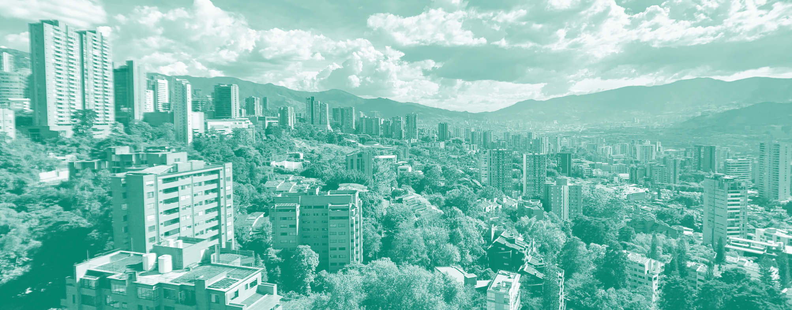

Innovative Financing Mechanisms to Achieve the Sustainable Development Goals in Colombia
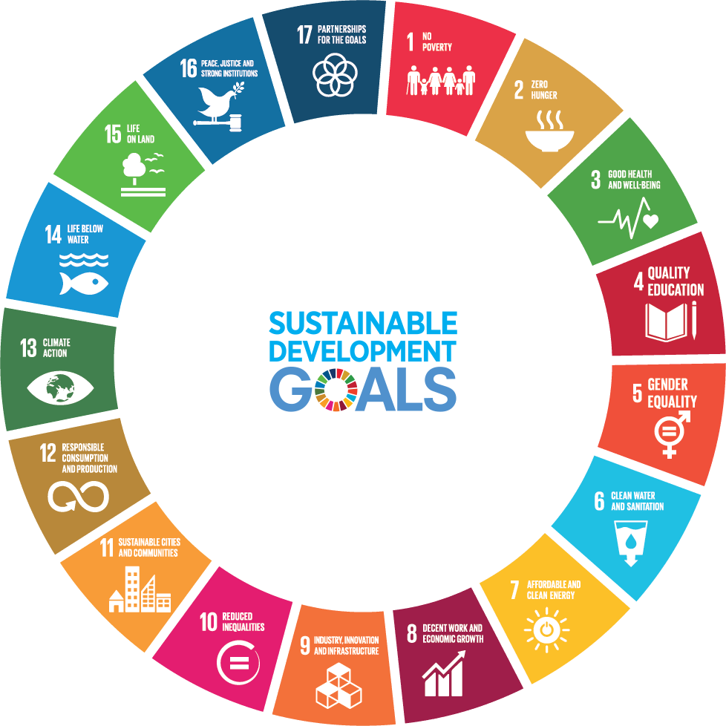

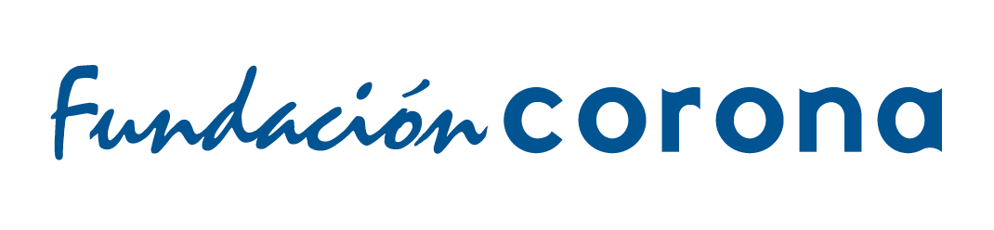
Aline Guzik, Ashkan Khayami, Basbibi Kakar,
Heidi Cao, Isabel de Katona, Valeria Cantu

Table of contents

1. Project Rationale & Objectives 6
2. Background 9
2.1. Colombian National Context 9
2.1.1. Introduction 9
2.1.2. Peace Process 9
2.1.3. Recent Elections & Protests (2019) 9
2.1.4. COVID-19 Pandemic 10
2.2. Sustainable Development Goals (SDGs) in Colombia 11
2.3. What is Innovative Finance? 16
2.4. Innovative Finance in Colombia 19
3. Research Methodology 24
4. Results 24
4.1. Estimating the Localized Financing Gap 24
4.1.1. Foundational Work on SDG Metrics and Benchmarking 24
4.1.2. Public Municipal Financing Sources: IPU & ICA 27
4.1.3. Proposed Methodologies: AidData & The Urban Institute 28
4.2. Stakeholder Analysis 32
4.2.1. Ecosystem Overview: Actors and Roles 32
4.2.2. Financing Instruments 35
4.2.3. Challenges 35
5. Case Studies 38
5.1. Output-Based Aid (OBA) in Urban and Sanitation in Ghana:
Creating a market for toilets 40
5.2. Pay-for-Success in Education for Employment: The Case of Massachusetts 42
5.3. Crowdfunding Peace: The Innovative Finance for Sustainable Peace Initiative 43
6. Recommendations 45
6.1. Innovative Financing Mechanisms 45
6.2. Financing Gap 45
6.3. Case Studies 46
6.4. Advocacy 46
6.5. Public Sector 46
6.6. CSOs 47
6.7. Ecosystem 47
6.8. Data, Metrics, and Indicators 48
6.9. COVID-19 48
7. References 49
8. Appendix 54
8.1. Colombia’s Milestones Towards the 2030 Agenda 54
8.2. List of Interviewees 55

Tables

Table 1: Selected SDGs, Targets and its Indicators 6
Table 2: Colombia’s Milestones Towards the 2030 Agenda 12
Table 3: List of Innovative Financing Mechanisms 17
Table 4: Financing Gap Methods 29
Table 5: Ecosystem Layout 34
Table 6: Relevant Case Studies 38
Table 7: Colombia’s Milestones Towards the 2030 Agenda 55
Table 8: List of Interviewees 56

Figures

Figure 1: Resources Available to CSOs by Thematic Area 20
Figure 2: Sources of Funding Accessible to CSOs 21
Figure 3: SDG 1 Progress Mapping 26
Figure 4: Total Additional Resources in Cartagena 28
Figure 5: Facilitation Types 33
Figure 6: Financial Flows Structure 42

Abbreviations
APC-Colombia | Presidential Agency for International Cooperation of Colombia
CONPES | National Council for Economic and Social Policy
CSOs | Civil Society Organizations
CRS | Common Reporting Standard
DANE | National Administrative Department of Statistics
DSP | Department of Social Prosperity
ELN | National Liberation Army
FARC | Revolutionary Armed Forces of Colombia
FDN | Financiera de Desarrollo Nacional
HLPF | United Nations High-Level Political Forum
ICA | Business Tax (in Colombia)
IDB | Inter-American Development Bank
IPU | Property Tax (in Colombia)
IFIs | International Financial Institutions
IMF | International Monetary Fund
NAB | National Advisory Board
NDP | National Development Plan
NEET | Not in Education, Employment, or Training population
NGOs | Non-governmental Organizations
NPD | National Planning Department
OBA | Output-Based Aid
ODA | Official Development Assistance
OECD | Organization for Economic Co-operation and Development
PPP | Public-Private Partnerships
PFS | Pay-for-Success
SDGs | Sustainable Development Goals
SIBs | Social Impact Bonds
UNDP | United Nations Development Programme
UNOSSC | United Nations Office for South-South Cooperation
USAID | United States Agency for International Development
VLR | Voluntary Local Review
VNR | Voluntary National Review

Acknowledgments
The SIPA team would like to thank our gracious client, Fundación Corona (Daniel Uribe, Natalia Borrero, Mónica Villegas, and Camila Zapata) for their invaluable insights, guidance, and seemingly infinite understanding of the circumstances under which this report was written. We would also like to extend our gratitude to our SIPA faculty advisors Eugenia McGill and José Antonio Ocampo, as well as Ilona Vinklerova for their support and feedback from the beginning of the project. Finally, we extend our sincerest gratitude to all of our interviewees, who, despite the global circumstances, took the time out of their schedules to speak with us candidly about our research topic and whose advice was indispensable to the completion of our project.

Executive Summary
Colombia—known in Latin America for its sound macroeconomic policies and significant social progress—recently became the 36th country member to join the Organization for Economic Co-operation and Development (OECD), opening a new chapter for its economic welfare. Yet, the country’s most recent attempts at progress have been hampered by recent civil unrest against a number of reforms, an influx of Venezuelan immigrants and the ongoing COVID-19 pandemic. Aside from its internal agenda, Colombia is one of the earliest proponents of the United Nations’ 2030 Agenda for Sustainable Development and the seventeen Sustainable Development Goals (SDGs) as a means to foster long-term peace and mitigate some of the world’s most pressing issues. The challenge now is to navigate the complex financial environment surrounding the implementation of this universal roadmap.
The team from Columbia University’s School of International and Public Affairs (SIPA) worked with Fundación Corona, as well as Professor José Antonio Ocampo, former United Nations Under Secretary General for Economic and Social Affairs and former Minister of Finance and Public Credit of Colombia. Between November 2019 and May 2020, they conducted wide-ranging research on the innovative finance ecosystem, with the intention of creating a resource for organizations from all levels in Colombia to realize the 2030 SDG Agenda for a stronger country and a more sustainable world.
The findings of the report emphasize three areas of research. The first are international case studies that underscore how innovative financial mechanisms can implement development projects. These include an output-based approach to incentivize a market for toilets in Ghana, the assessment of United States’ largest Pay-For-Success project related to educating for employment in Massachusetts and a crowdfund for peace as part of the Innovative Finance for Sustainable Peace Initiative. The second area are methodologies available to calculate financing gaps for the implementation of the SDGs in sub-national contexts. The third area is the team’s identification that a blended finance approach emphasizing results-based financing, direct equity and government risk mitigation when necessary holds the most promise for advancing the SDGs in Colombia.
The report concludes with recommendations for stakeholders in the Colombia development field on relevant methods of capital mobilization towards the advancement of the 2030 Agenda in Colombia, in light of the COVID-19 pandemic and the challenges the virus and the associated economic disruptions will pose to Colombia.

Project Rationale & Objectives
This report benchmarks successful innovative financing mechanisms and assesses the viability and scalability of SDG-focused approaches for the Colombian context. The scope of this project was narrowed down to fourteen targets within four SDG goals, though it is important to note that the SDGs are deeply intertwined and interrelated and so some projects may work towards achieving multiple SDGs, some of which are not the subject of this report. SDG 17, Global Partnerships for development, emerges throughout the report as national and international partnerships between the public and private sectors.
Table 1: Selected SDGs, Targets and its Indicators
No. | SDG/Target | Indicator(s)
4 | Quality Education
4.3 | By 2030, ensure equal access for all women and men to affordable and quality technical, vocational and tertiary education, including university | Participation rate of youth and adults in formal and non-formal education and training in the previous 12 months, by sex.
4.4 | By 2030, substantially increase the number of youth and adults who have relevant skills, including technical and vocational skills, for employment, decent jobs and entrepreneurship | Proportion of youth and adults with information and communications technology (ICT) skills, by type of skill.
4.5 | By 2030, eliminate gender disparities in education and ensure equal access to all levels of education and vocational training for the vulnerable, including persons with disabilities, indigenous peoples and children in vulnerable situations | Parity indices (female/male, rural/urban, bottom/top wealth quintile and others such as disability status, indigenous peoples and conflict affected, as data become available) for all education indicators on this list that can be disaggregated.
4.7.A | By 2030, ensure that all learners acquire the knowledge and skills needed to promote sustainable development, including, among others, through education for sustainable development and sustainable lifestyles, human rights, gender equality, promotion of a culture of peace and non-violence, global citizenship and appreciation of cultural diversity and of culture’s contribution to sustainable development | Extent to which (i) global citizenship education and (ii) education for sustainable development, including gender equality and human rights, are mainstreamed at all levels in: (a) national education policies, (b) curricula, (c) teacher education and (d) student assessment.
8 | Decent Work and Economic Growth
8.5 | By 2030, achieve full and productive employment and decent work for all women and men, including for young people and persons with disabilities, and equal pay for work of equal value. | - Average hourly earnings of female and male employees, by occupation, age and persons with disabilities  - Unemployment rate, by sex, age and persons with disabilities
8.6 | By 2030, substantially reduce the proportion of youth not in employment, education or training. | Proportion of youth (aged 15-24 years) not in education, employment or training
11 | Sustainable Cities and Communities
11.3 | By 2030, enhance inclusive and sustainable urbanization and capacity for participatory, integrated and sustainable human settlement planning and management in all countries. | - Ratio of land consumption rate to population growth rate  - Proportion of cities with a direct participation structure of civil society in urban planning and management that operate regularly and democratically
11.8.A | Support positive economic, social and environmental links between urban, peri-urban and rural areas by strengthening national and regional development planning | Proportion of population living in cities that implement urban and regional development plans integrating population projections and resource needs, by size of city
16 | Peace, Justice and Strong Institutions
16.6 | Develop effective, accountable and transparent institutions at all levels | - Primary government expenditures as a proportion of original approved budget, by sector (or by budget codes or similar)  - Proportion of the population satisfied with their last experience of public services
16.7 | Ensure responsive, inclusive, participatory and representative decision-making at all levels | - Proportions of positions (by sex, age, persons with disabilities and population groups) in public institutions (national and local legislatures, public service, and judiciary) compared to national distributions  - Proportion of population who believe decision-making is inclusive and responsive, by sex, age, disability and population group

This project builds on past SIPA collaborations with Fundación Corona that helped the client map the ecosystem for social impact bonds in Colombia, which has evolved into an Outcomes Fund to promote public innovation, as well as to develop a tool with Cómo Vamos that expands monitoring and evaluation capacities for local progress towards achieving SDGs in 16 cities.
The objectives of this project are to identify:
- Promising tools to harness various forms of innovative finance to advance the SDG agenda;
- Successful case studies worldwide where innovative financing vehicles have already been implemented for social projects;
- Methodologies to estimate the costs associated with fulfilling the SDGs in Colombia at the municipal level; and
- Existing public policy that can be expanded upon to foster a supportive environment for innovative finance mobilization.

Background

Colombian National Context

Introduction
With the exception of 2017, Colombia has enjoyed the highest percentage of GDP per capita growth in the region since 2011, above both Brazil and Argentina. Despite its relatively robust economic performance, Colombia, like its neighbors in Latin America, is experiencing a moment of socio-political tension. Security concerns and socioeconomic issues arising from economic inequality coupled with the regional fatigue of endemic corruption have led to a change in political leadership and the acceleration of a national strike movement that continues to grow its support within civil society.

Peace Process
The Colombian Peace Process with the Revolutionary Armed Forces of Colombia (FARC) passed under President Juan Manuel Santos in 2016, ended one of the longest running conflicts in the world. After winning the presidency, Iván Duque encountered resistance in the legislature and courts who rejected his modifications, which they feared would exacerbate the crisis. Since then, President Duque has softened his stance on the peace plan, with the number of remobilized dissident-FARC guerillas decreasing steadily. Despite impunity for killing social leaders in lawless areas, the work of truth commissions and reintegration efforts are progressing steadily. The government is now more focused on addressing the threat by the National Liberation Army (ELN) who announced a ceasefire in the wake of the COVID-19 outbreak.

Recent Elections & Protests (2019)
The most recent regional elections were seen by many as a referendum on the performance of President Duque and his center-right party, Democratic Center. Perhaps the most notable takeaways are the significant gains by non-traditional, smaller, center-left parties in the big cities of Colombia – Bogota, Medellin, Cali, Santa Marta, among others. In the country’s capital of Bogota, Claudia López of the Alianza Verde Party was the paragon of this trend with around 35% of the vote. The move away from established parties like the Democratic Center conveys discontent with President Duque and the legacy the party carries from his party’s founder and ideologue, Álvaro Uribe. This was especially clear in Uribe’s loss of his hometown and party stronghold, Medellin. His candidate lost to both the Alianza Verde candidate and Independent, Daniel Quintero, who won by 0.3 percentage points. Also worth mentioning was the relatively poor performance of the still young FARC party, whose sole victory was the mayor ship of the Northwestern Town of Turbaco. This was the second time the FARC has participated in elections.
Almost a month after the elections, President Duque attempted to pass economic and social reform packages. These were rejected by major unions in Colombia who banded together in the National Strike Committee. Protestors took to the streets, including non-labor civil society elements such as indigenous groups, human rights advocates, students, and feminist groups. The stated grievances of the demonstrators have expanded to include indiscriminate airstrikes on criminal encampments that kill children, insufficient safety for social leaders and candidates for elected office, and the prevalence of systemic corruption—2017 Inspector General Report stated that corruption costs 10% of the national budget or $7.5 billion a year. However, like the rest of the region, protests in Colombia have been curtailed by the COVID-19 crisis which has forced governments to institute a nationwide quarantine. It is hard to discern whether the current health crisis will exacerbate or temper the grievances of protestors in the long term.

COVID-19 Pandemic
On March 6th, Colombia confirmed its first COVID-19 case. As models predicted, the virus spread rapidly and by March 24th, President Duque announced a nationwide quarantine that has been extended to May 25th. At the time of publication, the virus has infected more than 4.41 million people and killed more than 302,000 worldwide. However, the trend line shows that social distancing is reducing the rate of infection. It is too early to make any strong predictions about the economic outcomes, but if mitigation efforts continue to reduce the infection rate, Colombia’s economy will most likely suffer less than other Latin American countries. According to a partially released International Monetary Fund (IMF) report, Colombia’s predicted 2020 GDP contraction (-2.4%) will be the second smallest after Paraguay (-1%). While a 2.4% contraction will no doubt present fiscal and economic challenges, it is lower than the regional average of a 5% contraction. It is important to note that Colombia’s relatively high unemployment is also projected to increase in 2020 (from 10.5 to 12.2%), which was one of the main grievances of protests late last year.

Sustainable Development Goals (SDGs) in Colombia
In September 2015, 193 countries came together to adopt the Resolution A/RES/70/1, better known as “Transforming Our World: The 2030 Agenda for Sustainable Development,” the most ambitious collective action ever taken to address several of the planet's most crucial issues. In the words of Mr. Ban Ki-moon, former Secretary-General of the United Nations, “It is a roadmap to ending global poverty, building a life of dignity for all and leaving no one behind” . The 2030 Agenda comprises 17 Sustainable Development Goals and 169 targets. As the global development system transitions from the Millennium Development Goals to the Sustainable Development Goals, the focus is on the integration of sustainable development and the capacity to incorporate them into national policy designs through mechanisms of High-Level Political Forum (HLPF) and Voluntary National Reviews (VNRs), in which countries discuss their progress and challenges in the implementation of the 17 goals.
Colombia is not only one of the signatories but has incorporated the SDGs into its National Development Plan (NDP), which was drafted in June 2015. In fact, 92 goals of the 2030 Agenda were already included in the country’s NDP months before countries signed the universal pledge. Colombia had set up the “High-Level Interagency Commission to implement the SDGs” as a way to effectively design policies aligned to the 2030 Agenda, and to meticulously monitor and evaluate each target and their corresponding goal. This Commission, chaired by the head of the National Planning Department (NPD), is comprised of seven members, who are ministers or high-ranking public officials from the; Office of the President, Ministry of Finance and Public Credit, Ministry of Foreign Affairs, Ministry of Environment and Sustainable Development, National Administrative Department of Statistics (DANE), Department of Social Prosperity (DSP), Presidential Agency for International Cooperation of Colombia (APC-Colombia), Administrative Department of Science, and Technology and Innovation.
The table below details Colombia’s standing in relation to the 2030 targets for the SDGs studied this report - no. 4, 8, 11 and 16. All four SDGs require additional growth to reach the targets, in addition to accessible and sustainable funds to implement the required projects.
Table 2: Colombia’s Milestones Towards the 2030 Agenda
SDG |  | Indicator | Current standing* | 2030 Target
4 | Quality Education | Coverage in higher education | 52.8% | 80%
8 | Decent Work and Economic Growth | Rate of labor formality | 51.8% | 60%
11 | Sustainable Cities and Communities | Percentage of urban households with a quantitative housing deficit | 5.2% | 2.7%
16 | Peace, Justice and Strong Institutions | Homicide rate | 25.8 | 16.4

Source: In-house production, using data from the National Planning Department and the United Nations Development Programme
*Year ranges from 2016 to 2018 depending on the available data.

According to the NPD, since 2015, Colombia has participated in several local and regional meetings regarding the 2030 Agenda and the path towards sustainable development. Most notably, the country was part of the 2018 Voluntary National Review (VNR), which was a watershed moment for Colombia, as President Santos’ peace deal with the FARC put an end to a conflict that lasted for more than half a century. It is important to emphasize the importance of this accord for the country, as one cannot think of sustainable peace and prosperity without navigating the particular challenges surrounding the continuous presence of armed groups. At the same time, the country was experiencing economic hardships due to the fall in fuel prices, despite having just been accepted as a member of the OECD.
The 2018 VNR process showcased five key challenges for Colombia in the framework of the 2030 Agenda, as stated by Luis Fernando Mejia, head of the National Planning Department. These include:
- Consolidating an efficient measurement system based on indicators and data;
- Ensuring the “Leave No One Behind” principle by breaching the regional and gender gaps, among other disparities that hamper a just and inclusive society;
- Identifying and leveraging new sources of funding;
- Incorporating new and unconventional governance strategies to develop more coherent policies; and
- Engage a wider variety of non-state actors to implement the SDGs under a multi- stakeholder approach.

Special focus must be placed on the financial barriers that have hampered progress towards the 2030 Agenda. In this regard, further reading of the statement made at the 2018 HLPF tells us some of the measures employed. The Colombian government has imposed a new fiscal strategy which has proven to be instrumental in increasing financial resources allocated to different programs in compliance with the SDGs. Examples include taxing plastic bags, which accounted for 3 - 7 million USD in the first six months post- implementation and resulted in 71% of households decreasing their usage by 30%. Another example is carbon taxing (with the exception of carbon neutral enterprises) that intends to eliminate 4.3 million tons of CO₂ by 2030.
Another source of public finance is “obras por impuestos”, whereby companies can decide either to pay the total amount of their taxes or pay half the amount and then funnel the remainder towards construction in zones with high levels of conflict in 344 municipalities. This policy has directed resources toward road construction, public education, as well as water and sanitation systems in 12 municipalities. It is also important to point out that Colombia’s legal framework not only allows, but also encourages public-private partnerships (PPP) for infrastructure projects, which has resulted in its third place ranking high up on the World Bank’s Procuring Infrastructure list.
President Duque has demonstrated that he wants to work through the SDG framework to meet the development needs of his country. In mid-March, President Duque signed an agreement with the United Nations called the “Framework of Cooperation for the Sustainable Development in Colombia” from 2020-2023, which will strengthen the VNR process and integrate the United Nations. support to the most critical parts of the National Plan of Development. The APC-Colombia, founded in 2011, was designed to serve as a mediator between different stakeholders in an effort to mobilize capital and guide the country’s international cooperation. The goal of the APC-Colombia is to set priorities and ensure alignment between the development cooperation, the NDP and foreign policy. It also compiles Colombia’s best practices to be shared with other countries. In 2018 the APC-Colombia and United Nations Office for South-South Cooperation (UNOSSC) jointly produced a “Colombia Has Changed” report highlighting, education and innovation, infrastructure, environmental protection and sustainability, peace and security, economy, tourism, trade, social welfare and international development cooperation.
His 2018-2022 NDP underscores rule of law as one key priority of the government. In this respect, the “pact for legality” aligns with the 2030 Agenda as it focuses on SDG 9 (Industry Innovation and Infrastructure), SDG 10 (Reduced Inequalities), SDG 14 (Life Below Water), SDG 16 (Peace, Justice and Strong Institutions) and SDG 17 (Partnerships for the Goals). The administration is focusing on promoting achieving equality and business development by supporting small businesses and is very open to using the United Nations platform system to exchange successful practices, which opens new channels for international cooperation. This framework will allow the government to prioritize investing in projects that touch upon some indicators that relate to aforementioned sectors. President Duque himself has actively participated in the United Nations HLPF and the General Assembly.
The Government of Colombia produced a report on incorporating the SDGs into local government development plans for 2016-2019, with four steps proposed:
- Coordinate the local government program with the SDGs;
- Complete the diagnosis by compiling and analyzing information on the current status of the territory with regard to achievement of the Goals;
- Formulate a strategic plan by defining indicators and the goals of the territorial development plan within the framework of the SDGs; and
- Mobilize resources, starting by identifying sources at different levels of government, needed for the department or municipality to contribute to the achievement of the Goals.

Local administrations are in the process of developing their Development Plans, and in line with the Cómo Vamos Cities Network, are including metrics to monitor advancement towards the SDGs and are working to ensure the allocation of current and future funding.
Colombia still faces a financing gap to the implementation of the SDGs, and a demand for information on how large the gap is. First and foremost, it needs to ensure a permanent and sustainable budge to achieve this goal. The budget would comprise contributions from all levels of government, the private sector, and international cooperation agencies, depending on the specific alliances and negotiated quotas. According to Colombia’s strategy for the SDG implementation, which is developed by the National Council for Economic and Social Policy (CONPES), the cost for implementing SDGs 4, 6, 7 and 11 alone totals 108.19 billions in Colombian pesos. The Financiera de Desarrollo Nacional (FDN), development bank in Colombia, has served as a risk mitigator in financing projects, mobilizing capital from local banks, international banks, and pension and insurance funds, and in 2012 the Colombian Congress passed a public private partnership law to reduce the government’s liability and create transparency mechanisms.
As the COVID-19 pandemic progresses, programs centered on the SDG agenda will face challenges in implementation and financing. The demand for certain programs and services may rise, thereby shifting organizations’ SDG financing priorities. This report’s findings, though focused on SDGs 4, 8, 11 and 16, are relevant to the SDG framework as a whole, regardless of changing circumstances.

What is Innovative Finance?
This study uses World Bank’s definition of innovative finance, which is described as “any financing approach that helps to:
- Generate additional development funds by tapping new funding sources beyond conventional mechanisms such as budget outlays from established donors and bonds from traditional international financial institutions (IFIs) or by engaging new partners, such as emerging donors and actors in the private sector;
- Enhance the efficiency of financial flows, by reducing delivery time and/or costs, especially for emergency needs and in crisis situations; and
- Make financial flows more results-oriented, by explicitly linking funding flows to measurable performance on the ground.”
In other words, innovative finance is a set of financial mechanisms that generate scalable and effective ways of mobilizing both private and public resources to solve pressing social and environmental global problems. This concept involves two sides as it is a complementary source of financial flows to development aid and it promotes an effective and efficient way of making development by linking financing to results, redistributing risks, increasing the working capital available, and leveraging technology.
Building on this definition, we mapped a list - which can be found below - of innovative financing mechanisms from our literature review that can be implemented by non-governmental organizations (NGOs). Some of these mechanisms are mentioned throughout the report, however, it is worth mentioning that not all of them were mentioned by our interviewees.

Table 3: List of Innovative Financing Mechanisms
Mechanism | Description
Crowd in Private Sector
Microfinance Investment Funds | Financing vehicles set up to invest in microfinance assets and in which social or commercial, private or institutional investors can potentially invest.
Impact Investment Funds | Financing vehicles set up to invest in companies that generate social and/or environmental impact as well as a financial return, and in which social or commercial, private or institutional investors (with different risk/return profiles) can potentially invest.
Direct Equity | An equity investment to take an ownership or stake in a separate for-profit entity, socially driven business or social enterprise.
Concessional Loans | Loans granted on more generous terms than market loans. This concessionality can be achieved through interest rates below those available on the market, longer maturities, longer grace periods, lower collateral requirements, or subordinated debt.
Guarantees | Similar to an “insurance policy” which provides a promise of loan repayments up to a specified amount in the case of default or non-performance. When guarantees are used to promote development in low income countries, they can provide the security needed to bring on board more private risk capital.
Catalytic Grant | Grants intended to support early-stage social enterprises that serve the poor; while these are not innovative financing instruments per se, they can serve as a critical bridge to attracting new forms of capital later.
Bonds | A typical bond is a debt investment in which an investor loans money to an entity (typically corporate or governmental) which borrows the funds for a defined period of time at a variable or fixed interest rate. Bonds can be used by companies, municipalities, states, and sovereign governments to raise money and finance a variety of projects and activities. However, in this context, we use the term to refer to debt financing raised specifically to fund social or environmental causes.
Improve Efficiencies
Performance-based Bonds | Results-oriented contracts that tie at least a portion of a contractor’s payment to the achievement of specific, measurable indicators linked to outputs or outcomes.
Impact Bonds | A contract among private investors, donors, and implementing agencies that have agreed upon a shared social outcome. Investors fund social programs in advance, and governments (under a social impact bond (SIB)) or third-party donors (under a development impact bond (DIB)) remunerate investors with financial returns if – and only if – evidence shows that programs achieve pre-agreed outcomes. Impact bonds are a way to shift incentives and accountability to results, transfer performance risk to the private sector, and increase efficiency in program implementation.
Debt-for-development Swap or Buy-downs | These occur when a developing country’s debt repayment obligations are transferred or reduced based on meeting development goals.
Conditional Cash Transfers | Transfers that aim to reduce poverty through payments from donors or governments to beneficiaries when beneficiaries fulfill certain conditions. These conditions are typically related to beneficiaries’ investments in human capital and use of services in health, nutrition, employment, and financial management.
Awards and Prizes | These mechanisms involve offering a financial reward for the delivery of a development solution in a competitive selection process. They are a type of results-based approach because prizes are not based on proposed solutions but on the results that the solutions deliver.
Advance Market Commitments | An agreement through which a donor commits to subsidize the future purchase of a product that is not yet available. Its purpose is to accelerate the development and availability of products like vaccines, in which pharmaceutical companies would otherwise not invest research and development due to low demand and recipient ability to pay.
Insurance Schemes | A form of risk management primarily used to reduce any substantial losses or gains suffered by an individual or an organization. In development, insurance schemes are widely used to increase the resilience of individuals, companies, and public entities to external shocks and reduce their future expenditures in case of a disaster.
Raise Additional Funds
Innovative Taxes | Specific taxes imposed by governments to raise funding for a specific development challenge. These initiatives generate new public revenue streams for development from the private sector.
Crowdfunding | The practice of funding a project or venture by raising monetary contributions from a large number of people and leveraging their networks for greater reach and exposure. It typically comes in four types: donations-based, rewards-based, lending-based, or equity-based, and helps finance projects that are too innovative or risky for traditional financing. Crowdfunding emerged from innovation in technologies that made it possible for businesses, NGOs, and individuals to secure funding with no or limited intermediation.
Voluntary Contributions | Part of consumer purchases that usually take the form of donations. Typically, these are private sector contributions (most often from individual citizens) facilitated or channeled by public authorities. They have the benefit of engaging a wider base of people into international development and humanitarian causes.

Source: Mechanisms and definitions obtained from InterAction’s report “Innovative Finance for Development: A Guide for NGOs”

Innovative Finance in Colombia
In 2017, Colombia became the first developing country to launch a social impact bond (SIB). In February 2019, the second SIB in Colombia and the third in Latin America was signed in Cali. Both SIBs seek to permanently place vulnerable populations into formal jobs. The SIBs.CO program in Colombia - formed by IDB Lab, the DSP, the Swiss Agency for Development and cooperation (SDC) and Fundación Corona - promoted the execution of these two SIBs and are advancing in the creation of an Outcomes Fund with the national government.
As noted in a report by CIVICUS and Innpactia, most of the resources accessible to Latin American civil society organizations (CSOs) were offered to multiple actors that, in many cases, were bigger and had more capacity to compete than smaller organizations. This indicates that Latin American CSOs, specifically smaller ones, must compete for high-in-demand resources on disadvantageous terms. The report found that 33% of the amounts accessible to CSOs and 58.7% of the funds exclusively accessible to civil society were provided from within Latin America. While 66.4% of the amounts exclusively available to Latin American CSOs were sourced from North America, Latin America provided 19.5% of the funds.
The authors controlled for resources available by development theme, as detailed in the table below. Especially noteworthy is the prominence of resources targeting projects on education, inequality and peace and justice is notable.
Figure 1: Resources Available to CSOs by Thematic Area
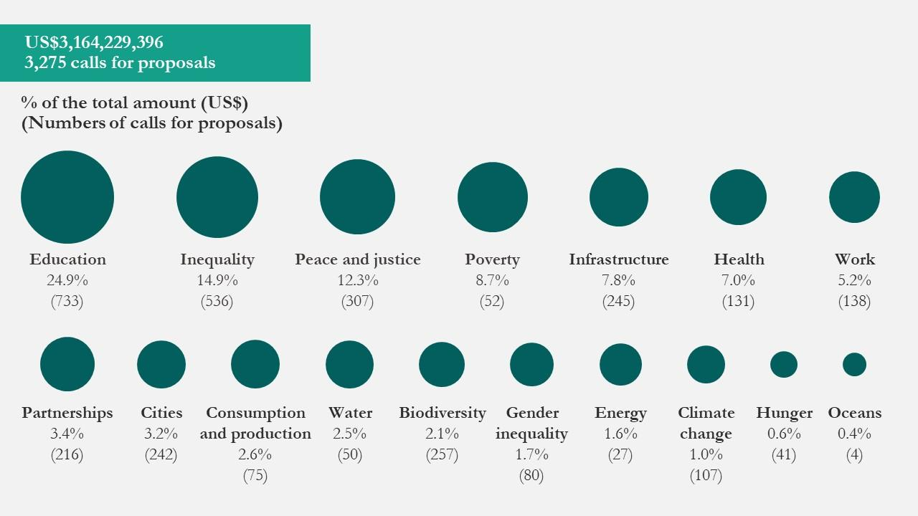
Source: CIVICUS & Innpactia

The figure below provides details on the sources of resources available to CSOs. State cooperation far outreaches the other sources at 50.6% of total resources, philanthropic institutions in second with 17.7%, and international cooperation following in third at 15.5%. Examples of strong philanthropic donors included the United States Agency for International Development (USAID), the United Nations Development Programme (UNDP), the Inter-American Development Bank (IDB), the European Commission, Colciencias, municipal governments and private foundations, chiefly Fundación Carolina, Oak, Macarthur, Ford and the J.P. Morgan Foundation. The Global Impact Investing Network (GIIN) accounts for 6.2 billion dollars available for impact investing in Latin America. Though alliance between several sources ranks last at 7%, the promise of this resource—blended finance—is being studied and pursued by CSOs and other institutions globally.
Figure 2: Sources of Funding Accessible to CSOs
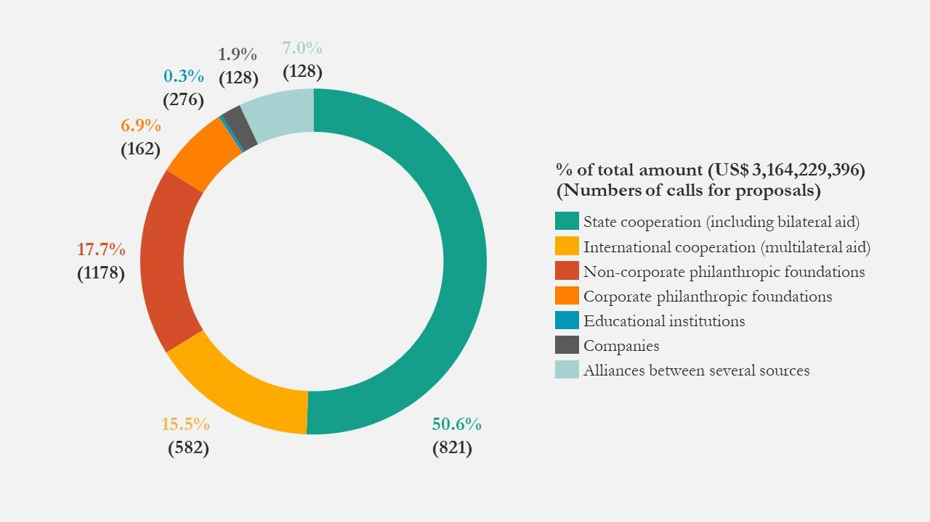
Source: CIVICUS & Innpactia

The Colombian government has centralized its social mobility platforms in the DSP and has created millionaire funds aimed at impact investing initiatives. The administration of President Duque included SIBs in the 2018-2022 NDP as a mechanism of innovation. This promising private and public environment presents development actors within Colombia with an exciting moment to advance their efforts to build on capital mobilization efforts. One of the key pillars is the support of Colombian entrepreneurs and small and medium enterprises to create 1.6 million jobs, increase employment formality to 41.2% and lower unemployment to 7.9%, among other goals. In early 2019 a group of executives in Colombia formed a task force to create a Colombian National Advisory Board (NAB) for Impact Investing to bring “cohesiveness, catalysis and articulation” to a field that is ready to launch further in Colombia. There are ample sources of social capital ready to be tapped into to finance development projects.
Colombia has the third largest private equity investments in Latin America, Central America and the Caribbean, with $771.6 million USD invested in 2017 according to the Latin American Venture Capital Association (LAVCA). The industry has over $16 billion USD in capital commitments, according to ColCapital. Public and private pension Funds are the country’s biggest institutional investors, accounting for $70.6 billion USD in assets under management according to the OECD. Of big and medium companies in Colombia, 70% have aligned social strategies with their daily operations. Finally, in the last LAVCA report, 5% of self-reported impact investors in Latin America were family offices.
In 2018, Concordia Innovative Financing Coalition identified a list of existing and soon-to-be launched funds in Latin America that may serve as sources of funds to CSOs and projects:
- Conservation International ‘Verde Ventures’ is a $14 million blended finance fund to seed early stage companies that deliver environmental, socioeconomic, and financial benefits. The fund has invested heavily alongside corporate partners like Starbucks in Colombia’s coffee industry.
- Fundación Corona helped launch a $1 million SIB that seeks to employ 1 million people.
- Financial Alliance for Sustainable Trade: Developed and implemented a platform (AXIIS) that connects entrepreneurs to various financial service providers with a total of more than $6 billion in available funding.
- Odiseo acts as the vehicle fund in Colombia for Capria Ventures LLC. Capria’s networks of investment targets initial investment ticket sizes of $500 K to $3 M as risk capital—venture equity, revenue-based financing, or mezzanine debt.
- Coca-Cola FEMSA is committed to investing $1 million in the Tocancipá area, to include: water sustainability across the region through its Replenish Project and entrepreneurship training for women and girls, with a focus on conflict victims.
- The Overseas Private Investment Corporation (OPIC) has committed nearly $700 million to infrastructure, housing, energy, and other projects in Colombia, and recently launched its 2X Americas Initiative to mobilize financing for women across Latin America.
- Inter American Peacebuilding Fund is a $600,000.00 fund for grassroots development and community-led initiatives dedicated to peace and reconciliation.
In November 2019, President Duque announced the creation of the Fund of Funds (Fondo de Fondos Colombianos), an alternative funding source for entrepreneurs and sustainable businesses. This instrument was created by the Minister of Commerce, Industry and Tourism in partnership with Bancoldex, Innpulsa, Colciencias, Softbank and the Latin American Bank of Development (CAF), as well as a number of private investors who reside in the country. The fund is made up of 38 million dollars meant to be transformed in private capital for social outcomes. All entrepreneurs are welcome to apply for the fund, as long as they prove to have a sustainable model for their business and a long-term outcome in which they either use the resources to achieve scalable social impact or use the money as start-up funds for other small business owners.

Research Methodology
The research methodology the team implemented was split between desktop research on the Colombian, innovative finance and development contexts, and interviews with relevant actors in the ecosystem. The results presented lean greatly on the information presented by the stakeholders interviewed, all of whom hold high-ranking and well-respected positions within their respective organizations, and in the development field, and are therefore well positioned to provide insight and advice on the topics being considered. The research was divided into the following four phases:
Phase 1: Desk Research
The team began by conducting desk research and literature review to analyze innovative financing, its role within Colombia, and mechanisms to be further studied.
Phase 2: Stakeholder Mapping
The team consulted with Fundación Corona and Jose Antonio Ocampo to develop a list of organizations that held a stake in the material and outcomes of the research.
Phase 3: Interviews
The team was originally scheduled to conduct in-person interviews in Bogota, Colombia in mid-March, but in light of the COVID-19 pandemic switched to virtual conferencing for the remainder of the project. In total, the team conducted interviews with 24 different stakeholders.
Phase 4: Analysis of information
The team analyzed the information collected in the interviews complemented by the desk research to emphasize findings and present recommendations to stakeholders at every level of the development ecosystem.

Results

Estimating the Localized Financing Gap

Foundational Work on SDG Metrics and Benchmarking
While the development field is familiar with the $2.5 trillion figure which represents the total global financing gap to realize the SDGs, there has been little work done on estimating the financing gaps in municipal level settings. The growing use of Voluntary National Reviews (VNRs) is an encouraging step, particularly Colombia which was one of the first to undertake such a review. However, a robust methodology for estimating financing gaps at the municipal level for SDGs has still not been developed. This is surprising given that there is demonstrable interest in benchmarking the progress of realizing the SDGs at the local level. Since 2018, select municipalities with the available resources have undertaken Voluntary Localized Reviews (VLRs) to show the progress a particular city government is making to realize select SDG goals at the local level. These VLRs go into detail about specific government projects and private sector collaborations, displaying metric data that shows success in progressing towards SDG indicators. But there is little to no discussion about the cost of these programs, the financial efficacy, or the remaining financial gap to reach the SDG.
Furthermore, past work from a prior Columbia University team and the continuing progress made by Cómo Vamos and Fundación Corona has made benchmarking SDG progress much easier and efficient. While there is still a lack of grassroots energy in advocating for local politicians to integrate the SDG framework more fully into their development plans, the tools to measure the impact of such efforts exist. In addition, Cómo Vamos has even done a lot of the analytical heavy lifting for municipalities by creating a “traffic light” benchmarking system reflecting SDG progress which can be monitored and classified as follows:
Figure 3: SDG 1 Progress Mapping
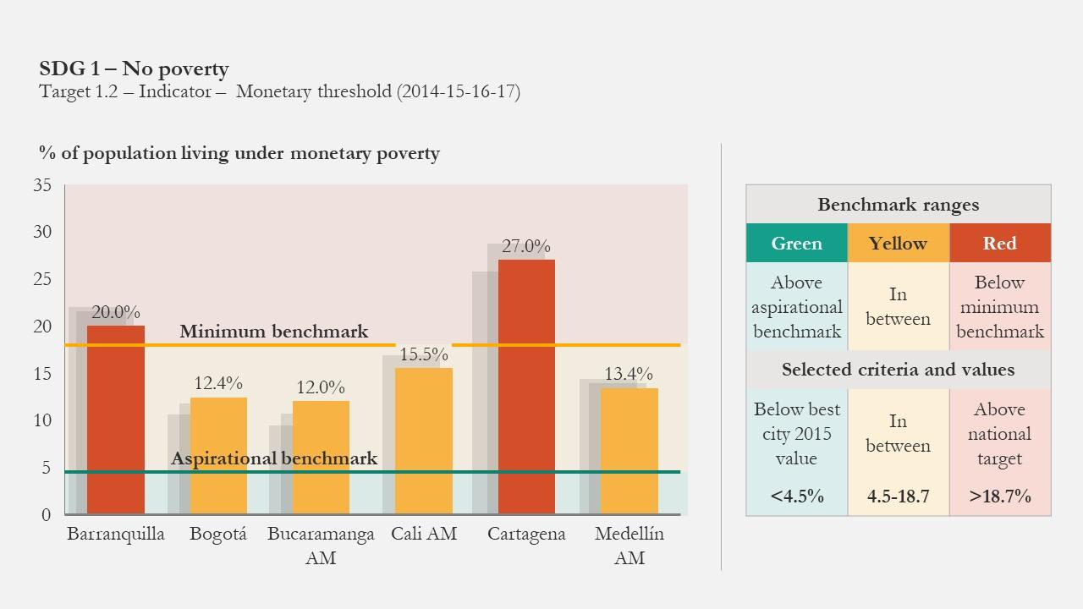
Source: TRENDS “Localizing the SDGs in Colombian Cities Through the Cómo Vamos City Network”
*Green: indicator is above the aspirational benchmark | Red: indicator is below the minimum benchmark | Yellow: indicator is between the aspirational and minimum benchmarks

Cómo Vamos has created a reliable, data-driven mechanism that allows decision-makers, civil society, investors, and even Colombian citizens to track not only their municipalities trajectory in achieving the localized SDGs, but also to compare their city’s performance with other cities in the country. The next step in building the localized SDG framework is creating a similarly data-reliant and robust system to connect the localized SDG impact to the underlying efficiency and availability of funding.
So far, collaborative efforts in Cartagena have yielded promising, yet preliminary, estimates for several SDGs, including no. 4 (Quality Education) and no. 8 (Decent Work and Economic Growth). Cómo Vamos, with the assistance of stakeholders like the Chamber of Commerce of Cartagena, devised a 2020-2023 municipal strategy to address SDG 4 which they estimate cost to be at 602 billion pesos. For SDG 8, the estimate comes to 4.129 billion pesos. Cómo Vamos has used the costs of these 2020-2023 SDG strategies and used them to make an even broader cost estimate extending to 2030: Education would cost 2.560 trillion pesos and Decent work and employment would cost 15.207 billion pesos. In order to compute these numbers, Cómo Vamos budgeted each of the projects needed to achieve the corresponding SDG. This is a sound methodology but could be difficult to scale-up or transfer to other municipalities.

Public Municipal Financing Sources: IPU & ICA
As important as innovative finance continues to be to realize the SDGs and unlocking new capital flows, improved public financing practices, as set out by Cómo Vamos, have the potential to unlock a sizable amount of funds for the next decade. Like most municipalities, Cartagena receives most of its revenues through two taxes: A property tax (IPU) and a business tax (ICA). As it stands, the property tax is not collected efficiently, leading to missing revenue. If collection can be improved even minutely by 1% to 2.5%, that could bring in revenues estimated between 1.3 and 2.3 trillion pesos to the municipal government. Additionally, if ICA is increased from its annual rate of 10% to 12%, this would bring in an estimated .5 - 1.1 trillion pesos. Therefore, together this IPU and ICA could generate 1.8 and 4.4 trillion pesos to the municipal government by the year 2030–as is demonstrated in the figure below. It is important to recognize that formalizing street vendors and small businesses will be a crucial element to this process as it will not only improve their quality of life but will also make collecting the mandated taxes easier and more cost-efficient.
Figure 4: Total Additional Resources in Cartagena
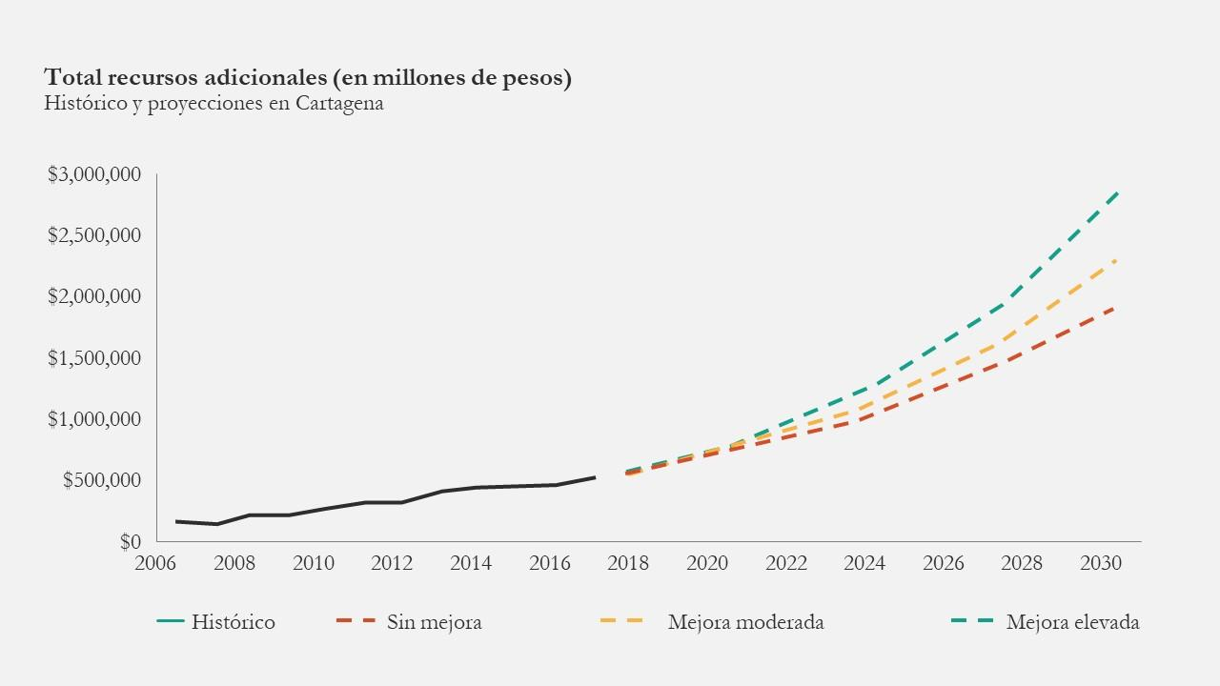
Source: Centro de Estudios Económicos Regionales (CEER) Banco de la República Seccional Cartagena

Proposed Methodologies: AidData & The Urban Institute
Even though there is no formalized attempt at estimating an SDG financing gap at the municipal level, there is a literature of proposed theoretical methodologies of estimating financing gaps. This could serve as a starting point to eventually develop a specialized analytical framework for financing SDGs at the municipal level. The first methodology is proposed by AidData, a research lab based at the College of William & Mary, which relies on available data from a plethora of sources such as OECD Common Reporting Standard-compliant data (CRS), from donors directly, national and municipal budgets, and aid management systems. The strength of AidData’s approach is that it emphasizes a codified approach to evaluating projects and outcomes and matches them either generally with an SDG target or the specific SDG target indicator whenever possible. Researchers and analysts at AidData look at the sources of project cost and performance data and codify them to one or several SDGs. This is a similar mode of databasing done by Cómo Vamos, which implies that these two systems might work in harmony at the localized level.
While this process is a robust attempt at estimating the financing gap for the SDGs, it does have several analytical and operational weaknesses. Analytically, the AidData database and reports are only as accurate as their underlying sources are. Though the OECD CRS format is not too hard to codify, it is still nevertheless very labor intensive as researchers have to interpret SDG performance data and match it to one or several SDG targets or indicators. Furthermore, they explain that donor reports and documents often use heavily generalized terms that make it hard to categorize its demonstrable impact. They use the example of vocational training programs, which can increase employment opportunities for their students, but is often not confirmed by outcome employment data. Perhaps most importantly, the current geographical scope of the AidData methodology analyzes metrics and outcomes only at the national level, not municipal level.
The next methodology was devised by the Washington D.C.-based think tank, The Urban Institute in the report “Measuring Community Needs Capital Resources and Capital Gaps” in which the authors lay out 11 Capital Gap Measuring Methods. Given that Colombia, like many other nations, is already low on private and public capital, five methods that are not too costly or labor-intensive are outlined below.

Table 4: Financing Gap Methods
Method |  | Description | Strengths | Weaknesses
1 | Ask Borrowers | Analyze demand-side of the capital gap, which includes retrieving quantitative data such as the capital demand, the types of capital being sought, and their denial or success rates.  Data could also include qualitative insights, such as how different borrowing groups choose whether to apply for loans, which capital products are most appealing etc. | - Will give a strong sense of the capital demand within a given municipality. | - Cost intensive to identify, recruit, and collect data from capital seekers.  - No supply-side perspective.  - Borrower interviews may not be sufficient to estimate gap size, especially at smaller geographies, depending on how many are conducted and the level of detail known and provided.  - Borrowers may not fully understand why they are having difficulty accessing credit and may believe a capital gap exists when rather their own creditworthiness is a fundamental issue.
2 | Ask Capital Providers (Lenders) | Analyze supply-side of the capital gap, which includes insights about capital supply barriers, market characteristics, new products, gaps in the market, and what capital providers look for in borrowers.  Providers may discuss loans that they would like to make but that current organizational policies or regulations prevent them from making, as well as loans that they would be willing to make if another capital provider were able to take on part of the deal (e.g., participation) or risk (e.g. a subordinate loan). | - Will give a strong sense of the capital supply within a given municipality.  - Lower in cost than demand-side analysis since there are fewer lenders than borrowers. | - No demand-side perspective.  - Provider interviews may not be sufficient to estimate gap size, depending on how many are conducted and the level of detail provided.  - Capital providers will not always have or be willing to give perfect information about their borrowers, so capital gaps may exist that they are not aware of.
3 | Asking Both Borrowers & Lenders and Estimating the Difference | Another approach to identifying capital gaps is to project the demand for capital and subtract the supply of capital available to generate an estimate of the unmet demand. | - This approach accounts for both capital supply and demand in a given market. | - Obtaining the data needed to accurately estimate demand and supply across capital type can be difficult and costly.
4 | Calculate Lending Denial and Frustration Rates | Identifying capital gaps by analyzing denial and/or frustration rates. Loan “frustration” refers to borrowers with incomplete or withdrawn applications or borrowers approved for a loan but on terms they do not accept. This amount of loan volume leading to a denied or frustrated borrower could be representative of the capital gap, which could be filled by increasing the availability of alternative credit, by providing credit enhancements to mainstream lenders, or by providing counseling and technical assistance. | - Denial and frustration can convey information about capital gaps, and data is often free, publicly available, nationally representative, longitudinal, and available at a small geography. | - Many capital types do not collect the detailed data needed to perform such analysis.  - Although some denied or frustrated borrowers could potentially be served successfully by mission lenders, not all of them are creditworthy.  - The data do not cover borrowers who were so discouraged they did not even apply for a loan.
5 | Compare One Moment to Another | Capital gaps can be identified by looking at changes in capital demand and flow across time. In particular, researchers may choose to look at how an economic shock or other disrupting event can affect capital utilization.  Analysts typically select a moment in time that the researcher deems to represent a reasonable or typical level of capital access and then compare that period to an abnormal one. | - Can provide quantitative evidence to identify the size of capital gaps and how shocks impact capital access.  - This method provides some empirical evidence of gap size. | - Distinguishing how much of a drop-off in investment activity is caused by investors tightening their standards, rather than a reduction in demand, is not always easy.  - Approach tends to be backward rather than forward looking.

Of the five methods, we recommend “Asking Both Borrowers & Lenders and Estimating the Difference” method, because it can be scaled and done in multiple cities. Of course, to undertake this analysis methodology, collaboration and data sharing will be essential. Researchers will need to access borrowing and lending data that is tied to specific SDG programs which are either held by banking associations, municipal chambers of commerce, or research institutions. We recognize that gaining this data might be time consuming, but we believe that it utilizes the most publicly available data, yields an accurate estimate, and will promote collaboration and buy-in from a multitude of stakeholders.
While finding a reliable municipal financing gap for the SDGs would help policymakers and promote local development, dissemination of the work would also be useful as an organizing and advocacy tool. Given that Colombia suffers from institutional problems like corruption and at times, political gridlock, communicating to Colombians the scope and breadth of financing gap to address problems like employment, sanitation, and peace could mobilize enough grassroots political capital to pressure policymakers and business leaders to move quicker on developing plans and projects for achieving the SDGs at the city level.

Stakeholder Analysis
Starting in February 2020, and continuing through March 2020, the project team conducted 22 interviews with relevant stakeholders, including UN agencies in New York and also in Latin America, foundations and NGOs located in the U.S. and in Colombia, a Colombian national government agency, leading university experts, and senior consultants. The team is fortunate to have had access to high-level stakeholders and to have obtained information on the current state of the Colombian ecosystem of innovative financing. Below the authors summarize key findings from these stakeholder interviews.

Ecosystem Overview: Actors and Roles
Although innovative financing is relatively young in Colombia, many actors are actively participating in the build-up of its ecosystem. Academic institutions such as universities in Colombia have recently established study centers with an explicit research focus on garnering the momentum and tools of innovative financing for fulfilling SDG funding gap and further development. The public sector, especially agencies charged with planning, are in the process of mapping funding needs as well as active stakeholders and potential allies in the private and nonprofit sectors. International firms and national firms continue to scale up their deals and investments using innovative instruments, particularly since the signing of the Peace Agreement. Impact investing, for instance, has been growing into a niche segment within the private equity industry in Colombia. In addition, annual conferences such as Concordia are bringing these stakeholders from the public, private, academic, and NGO sectors to the same platform, and facilitate meaningful discussions to accelerate the innovative financing movement and strengthen the ecosystem.
To map the stakeholders in Colombia, we will draw on the framework developed by Rebecca Tekula and Kirsten Andersen, which incorporates specified facilitating roles that stakeholders can take. While the framework is quite comprehensive, the Colombian context calls for ad hoc additions to it, which underpins the fact that every ecosystem is different. Furthermore, we would add to the framework more broadly, that advocacy work in generating will and interest in this field is a constant requirement. The four categories they propose in their framework are as follows:
Enabling: Creating optimal infrastructure and increasing productivity. Municipal and national governments and agencies can and should play a central role here through regulating the market and developing policy. In addition, particularly for the SDGs, the UN plays an important role as well in generating political will and enabling coordination between stakeholders. Although trade associations like the GIIN can develop comparative metrics, the Cómo Vamos program has filled the role in many Colombian municipalities as it continues to maintain a sophisticated SDG benchmarking and monitoring system. The framework also points to the work philanthropic organizations provide as early funding through grantmaking.
Improving: Fixing markets by making them more efficient. Governments have done some of the work here, but trade associations and networks - GIIN and Cómo Vamos - show more success in this role by providing outreach, networks, connections, and research resources. They also reduce deadweight loss of the market by matching investors with investees and providing an invaluable knowledge database. The authors also note that philanthropic organizations that have the capacity have also started to assume this role in some locales. Also, important to note is that any stakeholder which maintains coordinating or metric storage and analysis can improve their own internal efficiency to better facilitate interactions between different actors. In Colombia the government has also facilitated by creating panels like the National Advisory Board, which provides information to the ecosystem writ large and addresses imperfections impeding efficiency.
Moving: Moving markets on their margins, which reduces barriers to nonmarket goals. Governments may provide tax credits for impact investors while NGOs broadly may provide patient capital or first loss capital to an investee. Philanthropic organizations can play an important and often understated role of undertaking the initial risk early, which allows for other NGOs and sources of funding to become available–in other words, promotes blended finance.
Launching: Supporting the move of assets to market and developing in ways that yield growth. This role is quite straightforward as governments, philanthropic groups, and private capital play this role through providing the necessary funds.
Figure 5: Facilitation Types
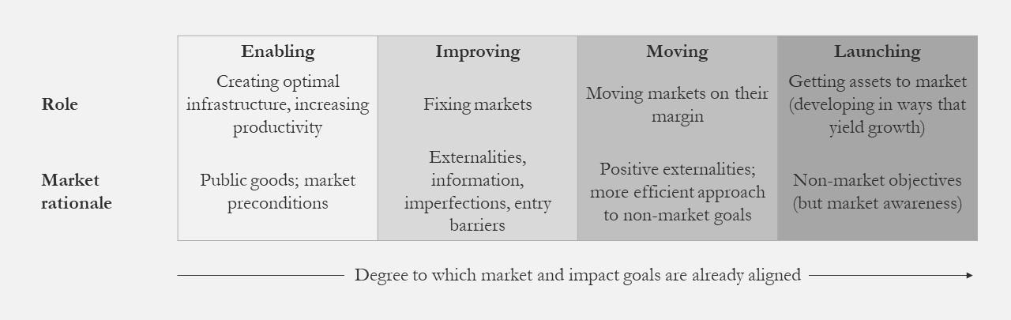
Source: Rebecca Tekula & Kirsten Andersen (2019) The Role of Government, Nonprofit, and Private Facilitation of the Impact Investing Marketplace, Public Performance & Management Review, 42:1, 146, DOI: 10.1080/15309576.2018.1495656

Table 5: Ecosystem Layout
Type | Enabling | Improving | Moving | Launching
Role | Creating Optimal Infrastructure; increasing productivity | Fixing Markets | Moving Markets on their margins | Getting Assets to Markets (developing in ways that yield growth)
Market  Rationale | Public Goods; Market preconditions | Externalities, information imperfections, Entry barriers | Positive externalities; More efficient approach to nonmarket goals | Nonmarket objectives (but market awareness)
Government examples | Property Rights; Transportation Infrastructure; Grantmaking | Regulation; Supportive Legislation; Credit Guarantees; Safe Harbor Provisions | Tax credits | Initial Capital
Trade Association Examples | Developing Comparable Metrics | Maintaining Impact Metrics; Technical Assistance; Convening
Philanthropy Examples | Grantmaking | Technical Assistance;  Convening | Patient Capital; First Loss Capital | Initial Capital
Private Capital Examples |  |  | Patient Capital; First Loss Capital | Initial Capital

Source: Rebecca Tekula & Kirsten Andersen (2019) The Role of Government, Nonprofit, and Private Facilitation of the Impact Investing Marketplace, Public Performance & Management Review, 42:1, 146, DOI: 10.1080/15309576.2018.1495656

Financing Instruments
The main challenge in identifying successful instruments is creating sustainability as a pathway to success. In advocating for these methods, it is necessary to challenge the assumption that investments with SDG impacts are not profitable. The obstacles of big investments for the SDGs are usually tied to risks that investors do not want to undertake. Green bonds and social bonds are the two instruments that are currently the most utilized in Colombia in mobilizing institutional money for the SDG agenda In addition to this, private equity, in the form of full or partial ownership of a social enterprise has emerged as a source of strength in that it engages investors that are willing to provide investment to the implementing agency which can be sustainable in the long run. Results and outcome-based approaches were applauded by most of the interviewees, as impact metrics serve as an important incentive to secure funding.
Blended finance would be an impactful instrument to further adopt and scale up - where multinationals, banks and development banks can jointly finance projects with the government. Blended finance - in the form of blended public private partnerships - has already been used on a large scale in Colombia for infrastructure, and it can incorporate more development funding sources as well as private sector stakeholders and can be applied more creatively to other sectors tied to SDGs.
Blended Finance has more impact than SIBs or private equity alone in closing the SDG gap due to its broader sphere of applications, and the opportunity presented to utilize various mechanisms. Regardless of any individual mechanism, the true question lies in how it interacts with other mechanisms. The stakeholders repeatedly emphasized the importance of case-by-case analysis of the financing mechanisms that will best serve the project in question.
Ultimately, the SDGs are not solvable with finance alone. In the case of Latin America, constraints exist in terms of growth and coordination problems amongst institutions. One stakeholder stated; "blended finance is one of the solutions to mobilize capital for SDGs. There needs to be more collaboration since the private sector cannot alone fill the $2.5 trillion gap." This highlights the interconnected nature of all the SDGs.

Challenges
One challenge for innovative financing for the SDGs lies in the knowledge gap and the “language barrier.” To scale a project, the organization needs to reach to the traditional sources in the banking sector and their corporate structure, who are not yet terribly familiar with the language of innovative financing.
Another challenge is that although SDGs serve as a convenient framework to come up with investment and project ideas, benchmarking for the SDGs may be harder. For instance, individually tracking a selected number of SDGs defeats the interrelated nature and purpose of the SDG ecosystem. It is important to look beyond the trendy instruments and use the right tool for the context. Having a myopic lens on specific SDGs potentially creates frenzy and misconception on the concentration of activities.
There needs to be a significant effort to promote payment for results and develop instruments for social development to overcome challenges due to disenchantment of government, impact investors and civil society. There is no easy way to disentangle the resource flows (public & private) to specific SDG targets and goals. Because private partners work at different levels (regional, municipal, and national) the DNP is asking the local government to create SDG-centric budgets. There is a culture of receiving money, creating a program, and then evaluating later. As mentioned before, Colombia is now considered an OECD developed country, and therefore all capital that is Official Development Assistance (ODA) or multilateral cooperation is being replaced by results-based financing. That is why an updated model of monitoring and evaluation to implement the financing options is essential. However, the collaterals are too high for the banks and International Financial Institutions so they can only commit for the current fiscal year. There is a lack of coordination between financing sources and project implementors: second level banks (like the FDN) - special banks that are not strictly commercial - can provide direct financing, and are partially private/public, but they are still private oriented projects and have a disconnect between the projects and the SDGs they are covering.
What is clear is that there needs to be a unified, if not standardized analytical process of assessing the impact of investing in SDG-centric projects, and a procurement and sharing of data between organizations and sectors. Currently, reporting is voluntary and the form in which performance metrics are conveyed is varied among various actors. There is always room for private sector engagement as long as the right incentives are there. It is noteworthy that the countries with less developed public financing arms rely heavily on private finance.
Finally, there is demand for increased coordination amongst stakeholders. An opportunity for coordination emerges in that traditional philanthropy in Latin America does not prioritize initiatives in peace, with the aid coming largely from international organizations. Improved coordination is also needed between financing sources and project implementors, for example with regard to 2nd level banks like the FDN - special banks that are not strictly commercial that provide direct financing and are partially private/public. The government and its national planning effort have played a key facilitating role in coordinating the private, public and non-profit sectors - but the public sector needs not be the only or the most dominant facilitator for innovative financing. In the U.K. the government started out the Nesta Innovation Fund, but then spun it off into a foundation as it realized the limitations of itself in playing the facilitator role. As a network, these initiatives can be strengthened and supported. NGOs can potentially assist in the coordination effort, as outlined in the recommendations section below.

Case Studies
Throughout the duration of this project, the team reviewed a variety of case studies that have used innovative financial mechanisms around the world. After thorough revision, three examples were chosen to study further. This section contains a list of all the case studies probed, a benchmark which we used to select three to focus on and a detailed analysis of the latter., which are marked in blue in the following table.
Table 6: Relevant Case Studies
Name | Sector/SDG | Financing type | Stakeholders | Objective | Results
Educate Girls Development Impact Bond in India | Education (SDG 4) | Impact Bond | UBS Optimus Foundation, Children’s Investment Fund Foundation, Educate girls, ID Insight, Instiglio | Enrolling out-of-school girls and improving quality education in marginalized communities | 116% of the enrolment target and 160% of the learning target in its final year
Mobile Money Transfers using Kiva | Education (SDG 4) | Microfunds | Kiva, private lenders and beneficiaries | Expand financial access to underserved communities | 1.4 billion USD lent through Kiva
African Guaranteed Fund for Small and Medium Enterprises | Employment (SDG 8) | Blended Finance | DANIDA (Denmark), AECID (Spain), African Development Bank, USAID | Boost access to finance for SMEs and stimulate employment creation through financial guarantees | $1.3 billion unlocked in financing capital  And increased SMEs and employment for Youth and Women in Africa
The Other Bar in Ecuador | Employment and Equality (SDG 8 and 10) | Private Investment | UNDP, FairChain Foundation, Hoja Verde, Clear Chox | Help cocoa farmers in Ecuador secure higher access to income by selling chocolate bars | Until now, they have sold 17,385 chocolate bars
Pay-for-Success in Education for Employment: The Case of Massachusetts | Education and Employment (SDG 4 and 8) | Pay-For-  Success | Roca, Goldman Sachs Social Impact Fund, The Kresge Foundation, Living Cities, the Laura and John Arnold Foundation, the New Profit, the Boston Foundation | Prevent vulnerable young people from becoming part of the Not in Education, Employment, or Training population in the State | Ongoing; expected to reduce incarceration by 40-60% and generate between 21.8 and 41.4 million USD in gross budgetary savings
Jesús Maestro Education Unit in Bolivia | Education and Employment (SDG 4 and 8) | Blended Finance | UNDP, Italian Cooperation (AICS), the Comune di Foligno, FELCOS | Improve the conditions and skills of these young people with intellectual disabilities | Participants learn basic life skills and sell their creations to earn money
ITELECOM Energy Efficient Street Lighting in Chile | Sustainable Cities (SDG 11) | Blended Finance | IDB Invest, Clean Technology Fund, Canadian Climate Fund for the Americas | Ensure long-term financing to replace traditional lamps with LED lamps for energy efficiency and decrease in public costs | Replacement of 62,200 streetlamps, reduction and CO2 emissions by 11,000 tons per year and increased energy savings
Creating a market for toilets in Ghana | Sustainable Cities (SDG 11) | Output-  Based Aid | Government of Ghana, World Bank and microfinance institutions | Improve sanitation in low-income communities to ensure cheaper access to toilets | As of June 2018, 7,685 toilets had been installed
The Innovative Finance for Sustainable Peace Initiative | Peace, justice and strong institutions (SDG 16) | Crowd  funding | IIX Foundation, the Business for Peace Foundation and multiple donors | Capitalize private investment to achieve sustainable peace | Ongoing; the goal is to reduce the $7 to 5 trillion dollars funding gap of the SDGs
Social Success Note | Multi SDGs | Pay-For-  Success | Yunus Social Business, the Rockefeller Foundation, UBS Foundation | Mobilize private sector capital to achieve greater good | Selling UV-filter systems to schools in Uganda so that 1.4 million children have access to clean drinking water
Zero Gap Fund | Multi SDGs | Impact Investing | 50 grantees including the Rockefeller Foundation and the MacArthur Foundation | Scale high-innovation financial mechanisms such as new securitizations, insurance products, and fund strategies to unlock new and additional private capital for impact | $2.5 trillion USD annual funding gap to implement the SDGs in emerging markets alone

As mentioned before, after careful consideration of all relevant case studies selected above, the team decided to focus on the three examples marked in blue in the previous table related to the pay-for-success education project in Massachusetts, output-based aid in Ghana, and the innovative finance for sustainable peace initiative. The selection criteria were based on the following: all projects are applicable to the Colombian context, though of course further revision of national and local interested parties must be considered. However, the three examples involve organizations which already work with Colombian stakeholders. Secondly, these examples show scalability due to the number of actors involved, the yielded or expected results, impact and scheme of the financial investment. Furthermore, all projects work under a result-driven approach, which as stated before, is critical to ensure an effective outcome given that their sustainable model is likely to prove viable in the long-term. Finally, these specific case studies are original in the universe of innovative finance, since their design is groundbreaking in itself.

Output-Based Aid (OBA) in Urban and Sanitation in Ghana:
Creating a market for toilets
According to the World Bank’s “Global Partnership on Output-Based Aid”, OBA is “an innovative approach to increasing access to basic services—such as infrastructure, healthcare, and education—for the poor in developing countries”. While OBA, also referred to as performance-based aid, has existed for a last decade, the World Bank came up with a new approach to this model that has proved successful. The multilateral organization partnered with the Government of Ghana, Metropolitan and Municipal Assemblies and financial institutions to launch a new water and sanitation project in the country.
The aim of the project was to improve affordability for households in crowded low-income areas located in the metropolitan area of Accra to invest in improved household toilets. Ghana’s citizens living near areas with rapid urbanization growth have difficulty accessing basic public infrastructure, such as education, health transportation, electricity, water and sanitation. In fact, only 23 percent of households have a toilet. Alternative funding for toilets in the household level from the private sector also proved difficult, due to the inability to cover the upfront costs of toilet installations. The financing mechanism used was a partial subsidy provided by the World Bank of 4.86 million USD. An additional 7.8 million USD were given in microloans by NGOs and microfinance institutions and a revolving fund was created to make funds available at low interest rates.
The OBA grant was distributed in the following way: a portion of the fund would cover the cost of building toilets, providing it met with the building requirements instructed by engineers and verified by an independent verification agent. Another portion of the grant would serve as an incentive to facilitate private investment in improved sanitation or, in other words, “building a market for toilets”. The private sector became engaged in the project because of the greater demand for toilets. This was done through a twofold strategy:
- Dissemination of the knowledge that toilets were now cheaper (due to initial subsidy); and
- Stricter imposed laws stating that all houses required to have at least one toilet.

As for the supply side of this newly created market was accompanied by technical assistance, transparency for data and credit enforcements, such as a guaranteed fund to share a percentage should losses in toilet installation occur and a creation of savings and loan products to increase sanitation investments.
As for the results at the end of the implementation program, “lowering the cost of the toilets by increasing the subsidy rate immediately affected the willingness to pay [on the part] of the target population”. The OBA subsidy played a crucial role in creating a market for finance investment in sanitation by allowing the population to have access to cheaper toilets. Additionally, the market information that became available, technical assistance provided by the World Bank and credit enhancements were also important to offset costs and risks. Finally, the conditionality clause linked to the quality of the installed toilets, served as a solid incentive for financial institutions. As of June 2018, 7,685 toilets had been installed as a result of this project.
Figure 6: Financial Flows Structure
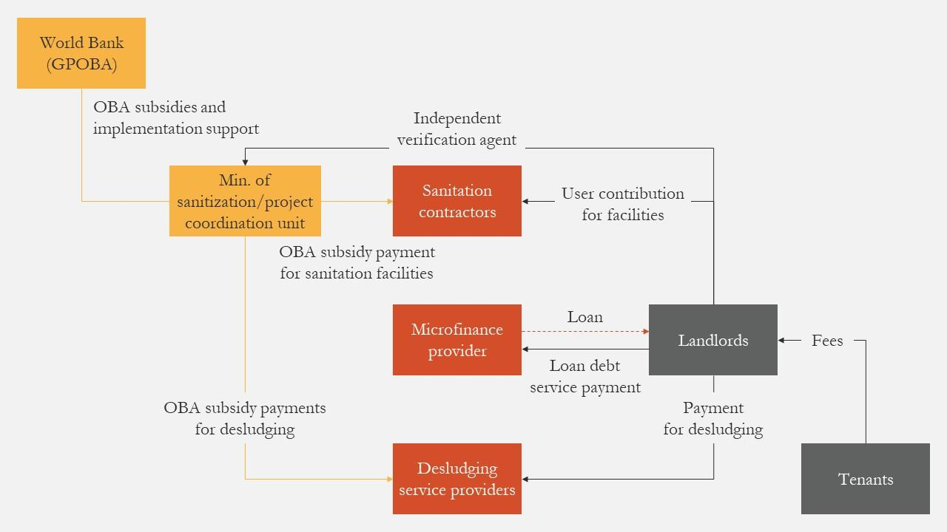
Source: GPRBA

Pay-for-Success in Education for Employment:
The Case of Massachusetts
Workforce development and vocational training have proven to be a successful intervention in terms of preventing young people, especially those who are most vulnerable, from becoming part of the Not in Education, Employment, or Training population (NEET). In the state of Massachusetts, United States, “64% of high-risk young men leaving juvenile incarceration or probation end up re-incarcerated within five years of release, and only 35 percent of this population is employed one year after release”. To support workforce development and recidivism, the Goldman Sachs Social Impact Fund, The Kresge Foundation, Living Cities, the Laura and John Arnold Foundation, the New profit and The Boston Foundation, along with the Third Sector Capital Partners serving as intermediate partner, provided a total 21.76 million USD in a combined grant and loan scheme to Roca Inc, a non-profit that works in job readiness and life skills training. The target population are 929 high-risk men aged 17-24 who were either on probation, serving parole, incarcerated or exiting the juvenile justice system. This is the country’s largest Pay for Success (PFS) project to date.
Roca works in a 4-year cycle through an evidence-based and data-driven intervention model measured by randomized controlled trial (RCT). Their intervention model has a life cycle of 4 years and it has proven successful partly due to their stage-based programming. Roca develops their curriculum based on their participants cognitive and behavioral needs, taking into consideration the hardships they face in their daily life. Their educational programs are certified as if they have completed high school and are adapted to disabilities, such as inability to read. The life skills curriculum also includes abuse groups, classes on healthy habits and parenting classes, teaching participants to become responsible members that can contribute to society. Finally, “the key piece of Roca’s employment programming is a Transitional Employment Program, in which participants join Roca’s work crews and earn real wages while learning basic work skills”.
The Commonwealth of Massachusetts was this project’s outcome payer, who would only yield payments if Sibalytics LLC and the Urban Institute, the third-party evaluators, could prove that this intervention avoided recidivism, improved job readiness and employment outcomes. Despite this being an on-going project, the outcome benefits are expected to be substantial. According to their financial projections, “at the project’s target impact of reducing incarceration by 40% the project would generate $21.8 million in budgetary savings, and at a 65% reduction the project would generate $41.5 million in gross budgetary savings”.

Crowdfunding Peace:
The Innovative Finance for Sustainable Peace Initiative
The Innovative Finance for Peace Initiative is a 5-year initiative launched by the IIX Foundation, as part of their work to “mobilize innovative financial mechanisms to unlock $1 billion, impacting 100 million lives, to drive forward sustainable peacebuilding efforts across the globe —in post-conflict countries, countries with high-risk of conflict and countries seeking to mitigate rising threats of violence by creating systemic social-economic resilience.” IIX is an impact investing firm located in Singapore focused on empowering vulnerable communities by including them in the global financial system.
The Innovative Finance for Peace Initiative aims to fulfill three overarching goals:
- Leverage financial markets by creating “business worthy corporates, equal communities and a resilient planet for all” ;
- Shift the narrative of prioritizing ending wars to building peace using a gender lens that sees women as solutions to peacebuilding instead of victims of war; and
- Reduce the $7 to 5 trillion dollars funding gap of the SDGs by “recognizing sustainable peace is both an enabler and an outcome of sustainable development and galvanizing key stakeholders from public, private and philanthropic sectors to join the movement.”
This initiative, supported by the Business of Peace Foundation, will be driven by a global Task Force based on a multi-stakeholder engagement, in which all members will pledge to ‘Commitments to Action’ in order to mobilize capital for sustainable peace with actionable results.
A key aspect of this initiative is that a significant part of the money will come from individuals who wish to donate via their website to the foundation to support the cause, in addition to the support provided by the partnership. As for impact metrics, the partnerships will implement the existing ‘Impact Assessment Toolkit for Peace, which measures social, economic and environmental outcomes, including gender-specific metrics. The IIX Foundation has promoted the use of technology to scale-up the Toolkit to be used by all the stakeholders involved.
In addition to this initiative, the International Peace & Security Institute (IPSI), in partnership with Creative Learning, launched the Venture Peacebuilding. This new vision for peace and prosperity brings together impact investors, social entrepreneurs and peacebuilding to “disrupt systems of violence, build peaceful and resilient communities and reclaim the $14 trillion global GDP annually lost to conflict.” This proposal was launched in January 2018 in the Venture Peacebuilding Symposium in Washington, D.C. and now works through the Online Collaboration Network of Venture Peacebuilders. Their Executive Report found that investment in scalable social businesses can stabilize conflict-affected communities while yielding financial dividends. They have called for action on reforming the silos in which peacekeepers, entrepreneurs and investors currently work in, and to strive for structural change in forming coordinated efforts amongst all stakeholders. In May 2019, they met in Bogotá, Colombia to discuss how to achieve peace in territories affected by armed conflict.

Recommendations

Innovative Financing Mechanisms
In addition to the existing SIBs in Colombia, the team recommends performance-based or results-oriented models, and private equity as financing mechanisms that provide the necessary incentives to promote a sustainable and successful project. These should be complemented with a blended finance approach that draws upon both instruments, as well as others available such as grants, government risk mitigation strategies, and SIBs, amongst others.
The instrument of innovative financing should be assessed and recommended on a project-by-project, case-by-case basis. The pool of the most appropriate financing tools is necessitated by the sector or the particular SDG, as each attracts different crowds of stakeholders and investors with divergent or competing appetites for risk as well as visions of acceptable returns. Ultimately, innovative financing allows for creativity in bringing about stakeholder alliances, and in the designing of details on deal structures and capital blending.

Financing Gap
To find an accurate estimate of the municipal level SDG financing gap, one can either try to use the AidData framework and augment it to analyze city level data or adopt method 5 from the Urban Institute: “Asking Both Borrowers & Lenders and Estimating the Difference.” No matter which method is used, they should be incorporated into the Cómo Vamos framework which has done incredible work in using data to benchmark local SDG progress. With time and capacity allowing, it may be beneficial to run both methodologies of estimating the financing gap to compare how close the estimates are and how one can shed light on the other’s flaws.
This sort of research is not only incredibly valuable for decision makers and civil society elites, but also in generating and galvanizing popular support for the urgency of the SDG agenda. Furthermore, beyond providing people with access to tools that allow them to judge the performance of their local leaders, they should be able to advocate and push for political action based on data driven research and analysis. This type of research would make this possible.

Case Studies
In the case of the market for toilets in Ghana, boosting a given product’s price to become affordable is a unique alternative to a revenue-generating model. As proved by the case study, both the demands for the population and the supplier needs were met. However, as repeatedly mentioned in our research, involving the government to enact the legal framework is a necessary step to create this market.
Similarly, the education for employment case in Massachusetts has been successful because of the resources provided by the Department of Labor. But an essential factor in this case is Roca’s promising approach. The lesson that stems from this case is the importance of selecting a promising implementation agency, not only acquiring the necessary resources.
Finally, the success of the crowdfunding for peace projects largely depends on the outreach strategy. If people are not actively involved, they will not likely make any contributions. Since this initiative has potential to work in Colombia, Fundación Corona would benefit from establishing a partnership with the organizations to replicate the initiative in Colombia in the future, whenever the economic and social conditions become adequate.

Advocacy
Communication and collaboration between the private and public sectors are fundamental to building a blossoming development ecosystem. Latin America has grantmaking organizations and impact funds, there is not necessarily a legal framework to help social enterprises, and therefore no in-between to mediate such relationships. Advocacy for a legal framework to support social enterprises could facilitate stronger public-private collaboration, as well as more efficient operations for development actors.
The National Advisory Board for Impact Investing has a key role in serving as such a facilitator for their broad understanding of the financing sphere, the actors involved, and their position as a mobilizer. The Cómo Vamos Cities Network is similarly positioned to incorporate the financing tools outlined in this report into local sustainable development plans, given their proven effectiveness at advocating for and facilitating innovative and sustainable development.

Public Sector
Colombia’s current strategy for international cooperation is driven by APC-Colombia. The country should continue to strengthen its international cooperation by building on the existing institutional infrastructure. By doing so, Colombia can scale up its efforts to exchange best practices with other countries, contribute to successful practices in the developing world, and join innovative global initiatives such as the ones outlined in this report. The APC-Colombia could lead the formation of a financing task force to tackle questions of risk mitigation to strengthen investor incentives.

CSOs
CSOs can help facilitate funding for the SDGs by addressing risks that are the most concerning to financial backers. The biggest challenge for CSOs adopting financing mechanisms is internal. They need to better assess their risk of return and innovate their business model and investor profile so as to not solely rely on money from donors. Impact and results measurement are key for an CSO in the coordinator or implementer role, as these can be used to document potential risk to future investors and establish internal metrics of performance. CSOs can mainstream these practices, as well as an innovative finance targeted mission, into staff training and objectives. Additionally, there is minimal investment in core operations, strengthening and sustainability of CSOs, with most of the resources being directed at project implementation, highlighting a need for innovative pivots to diversify the funding sources, and to practice blended finance, in order to meet the demand in financing the gaps in sustaining the organizations, as well as continuing to implement projects.

Ecosystem
Following our discussions on the current ecosystem in Colombia, the project team recommends each stakeholder to identify and strengthen its appropriate role by function: enabling, improving, moving, and launching. To summarize earlier findings, municipal and national governments, as well as trade associations, can play the central role of enablers by regulating the market and by developing policies. They can also improve markets with underlying externalities, information asymmetry and entry barriers. In terms of moving and channeling capital, the government can provide further tax credits while NGOs provide patient capital. Finally, in terms of launching innovative financing products with optimistic yield, governments, philanthropic groups and private capital can all pitch in by providing the necessary funds.
Drawing from stakeholder interviews, literature review, and the institutional logic of venture capitalists and commercial-value-driven entities, the project team believes that one of the most important relationships within the field is that between the investors and the investees. We hereby suggest several recommendations regarding this relationship in order to promote the ecosystem in Colombia, and thereby successful innovative financing practices. The utmost importance is attributed to due-diligence, which ensures consensus on the desired social and commercial-value generation from both sides of the deal. Proper due-diligence and information gathering also build a robust foundation for a collaborative long-term relationship, which needs to be sustained and reinforced through monitoring and evaluation practices. It is equally important to note the sector specialization of investors, which would allow for not only better outcomes in the selection process of investees, but also in the ongoing knowledge-sharing that must happen between stakeholders. Finally, it is vital for all parties involved to articulate their social and income expectations, in addition to the timeframe, viability, and scalability.

Data, Metrics, and Indicators
CSOs, investors, and even evaluation agencies, must collaborate, agree upon, and implement a framework of more unified reporting standards of SDG metrics and project impacts data. Although the OECD's Common Reporting Standard was a step in the right direction, creating a reporting standard that allows evaluators and analysts to pair impact to specific SDG indicators is essential to improving reporting and evaluation efficiency. In 2018, The Global Reporting Initiative published a 2018 report “Integrating the SDGs into Corporate Reporting: A Practical Guide,” which lays out in detail a practical methodology for developing and reporting through an SDG lens. This goes to show that there is sufficient effort and acknowledgment of the flaws in reporting and retrieving varying, and sometimes even vague, impact data. What is needed now, is a broad-based consensus on and, even ideally adoption of, an SDG reporting standard.
Colombia has already demonstrated that it is willing to assess its development strategies in terms of the SDGs through the VNR and the adoption of many of the SDGs in its NDP. Colombia should soon endeavor to have one or more of its cities undertake a VLR as well, in order to show both the international community and its citizenry that recognizes the SDG framework and the urgency of the Agenda.
There are also ecosystem players in place that can enhance the global agenda, such as the various task forces within the United Nations, the Global Impact Investment Network (GIIN), and InterAction, an NGO-alliance based in Washington, D.C. They have produced valuable research and insights in addition to hosting conferences and surveys that facilitate and strengthen the multi-stakeholder alliance.

COVID-19
The COVID-19 pandemic will have a profound effect on the social and economic wellbeing of Colombia, and the world. There are a few macro trends that COVID-19 is likely to exacerbate, which could spell trouble for Colombia. The first and most glaring is the drop-in oil prices. Coupled with the Saudi-Russia dispute over increased oil production, COVID-19 has reduced the demand - and thus price - for oil, which will not only reduce Colombia’s GDP, but will also damage the revenue stream that the government would desperately need in order to implement an economic recovery plan. There are many moving parts to a globalized economy, but it is undeniable that COVID-19 will challenge the government’s short-term goals of providing economic relief to the most vulnerable communities as well as implementing policies that will lead to a swift economic recovery. Another side effect, though much more pronounced for countries like Brazil or Chile, is the drop of economic activity with China. Before the pandemic struck, China was increasing its investments in Colombia, specifically in infrastructure projects. But it is clear now that the inevitable economic recession will at the very least put strain on such investments as the Chinese government looks to rebuild at home.
The COVID-19 pandemic will negatively impact not only socio-economic and health conditions within Colombia, but also the willingness of previously amenable investors to contribute capital, as well as the financial resources available to the government. Local governments, who began their terms in January 2020, will face challenges negotiating their development plants with civil society given the pandemic restrictions. Development timelines will likely be pushed back, and the height of societal need raised. Rather than making obsolete the recommendations in this report, these circumstances highlight the relevance of the conditions outlined above - inter-organizational and sectoral collaboration, data sharing, government risk mitigation, and locally aimed SDG mapping – in continuing to provide and build on development goals through this challenging period.

References
- AidData, “Estimating Financing to the Sustainable Development Goals: Methodology Note for V2.0”, (July 2019), https://www.aiddata.org/publications/estimating-financing-to-the-sustainable-development-goals-version-2-0.
- Alcaldía de Santiago de Cali, “Cali lanza el segundo Bono de Impacto Social en Colombia”, https://www.cali.gov.co/desarrolloeconomico/publicaciones/145766/cali-lanza-el-segundo-bono-de- impacto-social-en-colombia/ .
- Al Jazeera, “China's strong push into Colombia”, https://www.aljazeera.com/ajimpact/china-strong-push-colombia-200221222239198.html
- Bancoldex, “Fund of Funds: The Smart Way to Grow”, https://www.bancoldex.com/noticias/fondo-de-fondos-inversion-inteligente-para-crecer-3426
- Baron, Eliana Salas., Marcela Aguilar Serrano, “Ruta estrategica: Para Dónde Vamos”, Cómo Vamos.
- BBC, “Colombia's ELN rebels call ceasefire over coronavirus”, (March 30, 2020), https://www.bbc.com/news/world-latin-america-52090169
- Brookings, “Death by bad implementation? The Duque administration and Colombia’s peace deal(s)”, (July 2018), https://www.brookings.edu/blog/order-from-chaos/2018/07/24/death-by-bad-implementation- the-duque-administration-and-colombias-peace-deals/
- Caracol, “Colombia y ONU firmaron marco de cooperación para desarrollo sostenible”, https://caracol.com.co/radio/2020/03/19/nacional/1584650053_190630.html
- CIVICUS, and Innpactia, “Access to Resources for Civil Society Organizations in Latin America”, https://www.civicus.org/documents/reports-and-publications/civicus+innpactia-report_september02.pdf
- ColCapital, Inversor, and SEAF, “Building a Colombian National Advisory Board for Impact Investing”
- Colombia Reports, “10% of Colombia government budget lost to corruption: Inspector General”, (October, 2016) https://colombiareports.com/10-colombia-government-budget-lost-corruption-inspector-general/
- Concordia Innovative Financing Coalition, “Issue Briefing: Innovative Finance in Colombia”
- CTF-Asset Management, “Decreto Número 0280 de 18 Feb, 2015”, https://assets.ctfassets.net/27p7ivvbl4bs/6f6ANej3LaaWSscoEq0oM0/ec2dec1112408e388de29f6c30e5e227/Decreto280_18.02.2015.pdf
- CTF Asset Management, “Documento Conpes - Estrategia para la implementación de los objetivos de desarrollo sostenible (ODS) en Colombia”, https://assets.ctfassets.net/27p7ivvbl4bs/c15L6fPoswiGYUy64Uy4k/d2d1c2b218757846743c6eb335d5b380/CONPES_3918_Anexos.pdf
- CTF Asset Management, “Metas ODS con alineación en el PND 2014-2018: Todos por un Nuevo País”, https://assets.ctfassets.net/27p7ivvbl4bs/5qlA8c4UrCGsyYeISe4wea/c7131d1ec399c71ee51a2ab1f1b4b434/92_Metas_ODS_en_PND.pdf
- El Tiempo, “¿Quiénes terminaron victoriosos y quiénes derrotados?”, (October 28, 2019), https://www.eltiempo.com/politica/partidos-politicos/ganadores-y-perdedores-de-las-elecciones-regionales-2019-427786.
- Fitch Ratings, “Fitch Downgrades Colombia’s Rating to ‘BBB -’; Outlook Remains Negative”, (April 2020), https://www.fitchratings.com/research/structured-finance/fitch-downgrades-colombia-rating-to-bbb-outlook-remains-negative-01-04-2020
- Fundación Corona, “Purpose”, (November 25, 2019), http://www.fundacioncorona.org.co/#/fundacion/purpose
- GPRBA, “Blended Finance: Building the Market for Urban Sanitation in Ghana”, (June, 2018), https://www.gprba.org/sites/gpoba/files/publication/downloads/2019-03/blendedfinance_ghana_sanitation.pdf
- GPRBA, “Output-Based Aid – Fact Sheet”, (February, 2018), http://www.gpoba.org/sites/gpoba.org/files/GPOBA_fact_sheet_english_0.pdf
- GRI, “Integrating the SDGs into Corporate Reporting: A Practical Guide, (2018), https://www.globalreporting.org/resourcelibrary/GRI_UNGC_Reporting-on-SDGs_Practical_Guide.pdf
- Guardian, “Colombia: thousands take to the streets in third national strike in two weeks”, (December, 2019), https://www.theguardian.com/world/2019/dec/04/colombia-protest-duque-bogota
- IIX, “Innovative Finance for Peace Initiative”, n.d. https://iixglobal.com/sustainablepeace/
- IMF, “The Great Lockdown” World Economic Outlook (Full Report to Follow in May 2020), https://www.imf.org/en/Publications/WEO/Issues/2020/04/14/World-Economic-Outlook-April-2020-The-Great-Lockdown-49306
- InterAction, “Innovative Finance for Development: A Guide for NGOs”, https://www.interaction.org/wp-content/uploads/2019/02/Innovative-Finance-for-Development-A-Guide-for-International-NGOs.pdf
- Inter-American Development Bank, “Bonos de impacto social: cómo Colombia innova en los programas de empleo”, https://blogs.iadb.org/trabajo/es/bonos-de-impacto-social-como-colombia-innova- en-los-programas-de-empleo
- New York Times, “Colombia Extends Coronavirus Lockdown Until May 11, but Some Sectors to Sectors to Remain Opens”, https://www.nytimes.com/reuters/2020/04/20/world/americas/20reuters-health-coronavirus-colombia.html
- Presidencia de la República, “Final Agreement to End the Armed Conflict and Build a Stable and Lasting Peace”, http://especiales.presidencia.gov.co/Documents/20170620-dejacion-armas/acuerdos/acuerdo-final-ingles.pdf
- Presidencia de la República, “Key figures of the National Development Plan”, https://id.presidencia.gov.co/Paginas/prensa/2019/190525-Cifras-clave-del-Plan-Nacional-de-Desarrollo-Pacto-por-Colombia-Pacto-por-la-Equidad.aspx
- Red Cómo Vamos, “Red de Ciudades Cómo Vamos”, http://redcomovamos.org/wp-content/uploads/2014/04/foro-urbano2_NataliaE.pdf
- Reuters, “Colombian high court rules FARC peace law must be sanctioned”, (May 2019), https://www.reuters.com/article/us-colombia-peace-court/colombian-high-court-rules-farc-peace-law-must- be-sanctioned-idUSKCN1T0035
- Reuters, “Poor residents of Colombia's capital protest lack of aid during quarantine”, https://www.reuters.com/article/us-health-coronavirus-colombia-protests/poor-residents-of-colombias-capital-protest-lack-of-aid-during-quarantine-idUSKBN21Y3B7
- Roca, “Pay for Success”, https://rocainc.org/work/pay-for-success/
- Roca, “Stage-Based Programming”, https://rocainc.org/work/our-intervention-model/stage-based-programming/
- Servon, Lisa J., M. Anne Visser, and Robert W. Fairlie (2011) “Estimating the Capital Gaps for Small Businesses In New York City”, Journal of Public Budgeting, Accounting & Financial Management 23 (4): 451–477.
- South-South Galaxy, “Colombian Presidential Agency of International Cooperation (APC - Colombia)”, https://my.southsouth-galaxy.org/en/data/colombian-presidential-agency-of-international-cooperation-apc-colombia
- Tekula, Rebecca., Kirsten Andersen (2019) “The Role of Government, Nonprofit, and Private Facilitation of the Impact Investing Marketplace”, Public Performance & Management Review, 42:1, 146, DOI: 10.1080/15309576.2018.1495656
- Telesurenglish, “Colombia’s Local Elections, Far-Right Uribe Loses Major Cities”, (October 27, 2019) https://www.telesurenglish.net/news/Colombias-Regional-Elections-Results-Revealed-20191027-0019.html
- Thematic Research Network on Data and Statistics, “Localizing the SDGs in Colombian Cities Through the Cómo Vamos City Network”, (April, 2019), Pg. 7, https://static1.squarespace.com/static/5b4f63e14eddec374f416232/t/5cb648867817f738d11ca998/1555449998211/LDASI-Colombia_April19.pdf
- UIA Open Yearbook, “Colombian Presidential Agency of International Cooperation (APC - Colombia)”, https://uia.org/s/or/en/1122277582
- United Nations in China, “Sustainable Development Goals Officially Adopted by 193 Countries”, http://www.un.org.cn/info/6/620.html
- United Nations Department of Economic and Social Affairs, “The Social Impact of COVID-19”, (April 6, 2020), https://www.un.org/development/desa/dspd/2020/04/social-impact-of-covid-19/
- United Nations Development Programme, “ODS en Colombia: Los retos para 2030”, https://www.undp.org/content/dam/colombia/docs/ODS/undp_co_PUBL_julio_ODS_en_Colombia_los_retos_para_2030_ONU.pdf
- UN ECLAC, UN CEPAL, “Quadrennial report on national progress and challenges in relation to the 2030 Agenda for Sustainable Development in Latin America and the Caribbean”, https://www.cepal.org/en/publications/44552-quadrennial-report-regional-progress-and-challenges-relation-2030-agenda
- UNOSSC, “APC-Colombia’s ‘Together We Cooperate’ website intends to share the country’s public policy experiences with the international community”, (Jan 8, 2018), https://www.unsouthsouth.org/2018/08/01/apc-colombias-together-we-cooperate-website-intends-to-share-the-countrys-public-policy-experiences-with-the-international-community/
- UNOSSC, “Colombia Has Changed - Innovations for Development”, (September, 2018), https://www.unsouthsouth.org/2018/09/14/colombia-has-changed-innovations-for-development-2018/
- United Nations Sustainable Development Goals Knowledge Platform, “Guión Preliminar - VNR Ministro Luis Fernando Mejia. COLOMBIA. Lunes 16 de Julio de 2018”, https://sustainabledevelopment.un.org/content/documents/27655statementbycolombia.pdf
- United Nations Sustainable Development Goals Knowledge Platform. “Objetivos de Desarrollo Sostenible.” https://www.ods.gov.co/es/objetivos
- United Nations Sustainable Development Goals Knowledge Platform, “Reporte Nacional Voluntario Colombia”, https://sustainabledevelopment.un.org/content/documents/20338Colombia_2018_VNR_Espan771ol_1.pdf
- Urban Institute, “Juvenile Justice Pay for Success Initiative”, (October, 2014), https://pfs.urban.org/pfs-project-fact-sheets/content/juvenile-justice-pay-success-initiative
- Urban Institute, “Measuring Community Needs Capital Resources and Capital Gaps”, (November, 2018), Print.
- Venture Peacebuilding, “VP Executive Report”, (January, 2018), http://venturepeacebuilding.org/wp-content/uploads/2018/04/VPS-Executive-Brief-FINAL.pdf
- World Bank Data, (December 11, 2019), https://data.worldbank.org/indicator/NY.GDP.PCAP.KD.ZG?end=2018&locations=CO-ZJ-BR-AR&start=2010&view=chart
- World Bank, “Innovative Finance for Development Solutions”, http://siteresources.worldbank.org/CFPEXT/Resources/IF-for-Development-Solutions.pdf

Appendix

Colombia’s Milestones Towards the 2030 Agenda
Table 7: Colombia’s Milestones Towards the 2030 Agenda
SDG |  | Indicator | Current standing* | 2030 Target
1 | No Poverty | Multidimensional Poverty Index | 17.8% | 8.4%
2 | Zero Hunger | Malnutrition mortality rate in children under 5 years of age | 9.0 | 5.0
3 | Good Health and Well-being | Maternal mortality rate | 51.35 | 32.00
4 | Quality Education | Coverage in higher education | 52.8% | 80%
5 | Gender Equality | Percentage of women in high-level managerial positions in government | 44% | 50%
6 | Clean Water and Sanitation | Access to clean and safe water | 91.9% | 100%
7 | Affordable and Clean Energy | Coverage of electric energy | 97.0% | 100%
8 | Decent Work and Economic Growth | Rate of labor formality | 51.8% | 60%
9 | Industry, Innovation and Infrastructure | Number of households with internet access | 53.2% | 100%
10 | Reduced Inequalities | GINI Coefficient | 517 points | .480 points
11 | Sustainable Cities and Communities | Percentage of urban households with a quantitative housing deficit | 5.2% | 2.7%
12 | Responsible Consumption and Production | Recycling rate and new use of solid waste | 8.7% | 17.9%
13 | Climate Action | Reduction of total greenhouse gas emissions | 0% | 20%
14 | Life Below Water | Thousands of hectares of marine protected areas | 12,539 | 13,250
15 | Life on Land | Thousands of hectares of protected areas | 30,271 | 30,620
16 | Peace, Justice and Strong Institutions | Homicide rate | 25.8 | 16.4
17 | Partnership for the Goals | Total exports as a percentage of GDP | 15.9% | 16.1%

Source: In-house production, using data from the National Planning Department and the United Nations Development Programme
* Year ranges from 2016 to 2018 depending on the available data.

List of Interviewees
Table 8: List of Interviewees
Organization | Interviewee Name
BanColombia | - Franco Piza, Director of Sustainability
The BC.lab | - Luc Lapointe, CEO & Founder
Center for Global Development (CSD) | - Nancy Lee, Senior Policy Fellow  - Asad Sami, Research Associate
Cepei | - Jaime Gallego, Data Researcher  - Javier Surasky, Governance for Development Area Coordinator
ColCapital | - Paula Delgadillo Sanz de Santamaría, Executive Director
Colectivo Traso | - Liliana Margarita Puello Lopez, Education Coordinator
Cómo Vamos | - Maria Claudia Penas Arana, Director, Cartagena Cómo Vamos  - Eliana Baron, Technical Coordinator, Cartagena Cómo Vamos  - Luis Hernan Saenz, National Coordinator of Red Colombiana de Ciudades Cómo Vamos
U.N. Economic Commission for Latin America and the Caribbean (ECLAC) | - Esteban Perez, Chief of the Financing for Development Unit, Economic Development Division
FSG | - Laura Amaya, Associate Director
Fundación Bolívar Davivienda | - Fernando Cortes McAllister, VP Corporate Social Responsibility
Global Impact Investing Network (GIIN) | - Sophia Sunderji, Senior Associate, Research
Henderson Alberro | - Irina Alberro, Partner & Co-Director of the Lab on Financing and Pay for Results
Innpactia | - Juan Lozano, CEO & Founder
InterAction | - Benjamin Bestor, Senior Program Associate, Global Development Policy and Learning
International Venture Philanthropy Center | - Carolina Suarez, Senior Advisor  - Juan David Ferreira, Consultant
Mission of Colombia to the United Nations | - Jaime Gnecco, Counselor  - Carolina Gutierrez, Third Secretary
Mutual Empathy | - Alejandro Calderon, Founder
National Planning Department (DNP) | - Camilo Garzon, M&E Director  - Olga Romero, Coordinator SDG Commission  - Adriana Cozma, Former Social Development Adviser
Organisation for Economic Co-operation and Development (OECD) | - Laura Abadia, Policy Analyst, Network of Foundations Working for Development
Pacific Community Ventures | - Bulbul Gupta, CEO
Resonance Global | - Elina Sarkisova, Senior Manager
U.N. Department of Economic and Social Affairs (UN DESA) | - Mathieu Verougstraete, Economic Affairs Officer  - Krishnan Sharma, Senior Economist
Universidad de los Andes | - Clemente Luis del Valle Borraez, Center for Financial Markets and Sustainable Infrastructure

Fundación Corona, “Purpose”, http://www.fundacioncorona.org.co/#/fundacion/purpose
World Bank Data, “GDP per capita growth, (annual %)”, https://data.worldbank.org/indicator/NY.GDP.PCAP.KD.ZG?end=2018&locations=CO-ZJ-BR-AR&start=2010&view=chart
Reuters, “Colombian high court rules FARC peace law must be sanctioned”, (May, 2019), https://www.reuters.com/article/us-colombia-peace-court/colombian-high-court-rules-farc-peace-law-must- be-sanctioned-idUSKCN1T0035
Brookings. “Death by bad implementation? The Duque administration and Colombia’s peace deal(s)”, (July, 2018), https://www.brookings.edu/blog/order-from-chaos/2018/07/24/death-by-bad-implementation- the-duque-administration-and-colombias-peace-deals/
BBC, “Colombia's ELN rebels call ceasefire over coronavirus”, (March 30, 2020) https://www.bbc.com/news/world-latin-america-52090169
Telesurenglish, “Colombia’s Local Elections, Far-Right Uribe Loses Major Cities”, (October 27, 2019) https://www.telesurenglish.net/news/Colombias-Regional-Elections-Results-Revealed-20191027-0019.html
El Tiempo, “¿Quiénes terminaron victoriosos y quiénes derrotados?”, (October 28, 2019), https://www.eltiempo.com/politica/partidos-politicos/ganadores-y-perdedores-de-las-elecciones-regionales-2019-427786
Ibid.
Telesurenglish, “Colombia’s Local Elections, Far-Right Uribe Loses Major Cities”, (October 27, 2019) https://www.telesurenglish.net/news/Colombias-Regional-Elections-Results-Revealed-20191027-0019.html
Ibid.
Guardian, “Colombia: thousands take to the streets in third national strike in two weeks”, (December, 2019), https://www.theguardian.com/world/2019/dec/04/colombia-protest-duque-bogota
Colombia Reports, “10% of Colombia government budget lost to corruption: Inspector General”, (October, 2016) https://colombiareports.com/10-colombia-government-budget-lost-corruption-inspector-general/.
Reuters, “Poor residents of Colombia's capital protest lack of aid during quarantine”, https://www.reuters.com/article/us-health-coronavirus-colombia-protests/poor-residents-of-colombias-capital-protest-lack-of-aid-during-quarantine-idUSKBN21Y3B7
New York Times, “Colombia Extends Coronavirus Lockdown Until May 11, but Some Sectors to Remain Opens”, https://www.nytimes.com/reuters/2020/04/20/world/americas/20reuters-health-coronavirus-colombia.html
Worldometers, “Colombia Coronavirus” https://www.worldometers.info/coronavirus/country/colombia/
IMF, “The Great Lockdown” World Economic Outlook (Full Report to follow in May 2020). https://www.imf.org/en/Publications/WEO/Issues/2020/04/14/World-Economic-Outlook-April-2020-The-Great-Lockdown-49306
United Nations in China, “Sustainable Development Goals Officially Adopted by 193 Countries”, http://www.un.org.cn/info/6/620.html
CTF Asset Management, “Metas ODS con alineación en el PND 2014-2018: Todos por un Nuevo País”, https://assets.ctfassets.net/27p7ivvbl4bs/5qlA8c4UrCGsyYeISe4wea/c7131d1ec399c71ee51a2ab1f1b4b434/92_Metas_ODS_en_PND.pdf
CTF-Asset Management, “Decreto Número 0280 de 18 Feb, 2015”, https://assets.ctfassets.net/27p7ivvbl4bs/6f6ANej3LaaWSscoEq0oM0/ec2dec1112408e388de29f6c30e5e227/Decreto280_18.02.2015.pdf
Find full table in Appendix 8.1.
United Nations Sustainable Development Goals Knowledge Platform, “Objetivos de Desarrollo Sostenible”, https://www.ods.gov.co/es/objetivos
United Nations Development Programme, “ODS en Colombia: Los retos para 2030”, https://www.undp.org/content/dam/colombia/docs/ODS/undp_co_PUBL_julio_ODS_en_Colombia_los_retos_para_2030_ONU.pdf
Presidencia de la República, “Final Agreement to End the Armed Conflict and Build a Stable and Lasting Peace”, http://especiales.presidencia.gov.co/Documents/20170620-dejacion-armas/acuerdos/acuerdo-final-ingles.pdf
This was the second time Colombia announced its VNR; the first was in 2016.
Refer to appendix 7.2 for statistics on Colombia’s position in achieving the SDGs.
United Nations Sustainable Development Goals Knowledge Platform, “Guión Preliminar - VNR Ministro Luis Fernando Mejía. COLOMBIA”, https://sustainabledevelopment.un.org/content/documents/27655statementbycolombia.pdf
Caracol, “Colombia y ONU firmaron marco de cooperación para desarrollo sostenible”, https://caracol.com.co/radio/2020/03/19/nacional/1584650053_190630.html
UIA Open Yearbook, “Colombian Presidential Agency of International Cooperation (APC-Colombia)”, https://uia.org/s/or/en/1122277582
South-South Galaxy, “Colombian Presidential Agency of International Cooperation (APC-Colombia)”, https://my.southsouth-galaxy.org/en/data/colombian-presidential-agency-of-international-cooperation-apc-colombia
UNOSSC, “APC-Colombia’s ‘Together We Cooperate’ website intends to share the country’s public policy experiences with the international community”, https://www.unsouthsouth.org/2018/08/01/apc-colombias-together-we-cooperate-website-intends-to-share-the-countrys-public-policy-experiences-with-the-international-community/
UN ECLAC, UN CEPAL, “Quadrennial report on national progress and challenges in relation to the 2030 Agenda for Sustainable Development in Latin America and the Caribbean”, https://www.cepal.org/en/publications/44552-quadrennial-report-regional-progress-and-challenges-relation-2030-agenda
Red Cómo Vamos, “Red de Ciudades Cómo Vamos”, http://redcomovamos.org/wp-content/uploads/2014/04/foro-urbano2_NataliaE.pdf.
United Nations Sustainable Development Goals Knowledge Platform, “Reporte Nacional Voluntario Colombia”, https://sustainabledevelopment.un.org/content/documents/20338Colombia_2018_VNR_Espan771ol_1.pdf
CTF Asset Management, “Documento Conpes - Estrategia para la implementación de los ODS en Colombia”, https://assets.ctfassets.net/27p7ivvbl4bs/c15L6fPoswiGYUy64Uy4k/d2d1c2b218757846743c6eb335d5b380/CONPES_3918_Anexos.pdf
Ibid.
UN Department of Economic and Social Affairs, “The Social Impact of COVID-19”, (April 6, 2020), https://www.un.org/development/desa/dspd/2020/04/social-impact-of-covid-19/
World Bank, “Innovative Finance for Development Solutions”, http://siteresources.worldbank.org/CFPEXT/Resources/IF-for-Development-Solutions.pdf
InterAction, “Innovative Finance for Development: A Guide for NGOs”, https://www.interaction.org/wp-content/uploads/2019/02/Innovative-Finance-for-Development-A-Guide-for-International-NGOs.pdf
Inter-American Development Bank, “Bonos de impacto social: cómo Colombia innova en los programas de empleo”, https://blogs.iadb.org/trabajo/es/bonos-de-impacto-social-como-colombia-innova- en-los-programas-de-empleo
Alcaldía de Santiago de Cali, “Cali lanza el segundo Bono de Impacto Social en Colombia”, https://www.cali.gov.co/desarrolloeconomico/publicaciones/145766/cali-lanza-el-segundo-bono-de- impacto-social-en-colombia/
Note: Our team is aware of other instruments in practice, such as green bonds. Green bonds in particular were one of the first examples of successful innovative finance in Colombia. However, following a conversation with our client, the team has been informed that green bonds are not as relevant or applicable to their work in the Colombian context. Therefore, this instrument will not be investigated in depth in this project.
CIVICUS, and Innpactia, “Access to Resources for Civil Society Organizations in Latin America”, https://www.civicus.org/documents/reports-and-publications/civicus+innpactia-report_september02.pdf
Ibid.
Ibid.
Ibid.
Presidencia de la República, “Key figures of the National Development Plan”, https://id.presidencia.gov.co/Paginas/prensa/2019/190525-Cifras-clave-del-Plan-Nacional-de-Desarrollo-Pacto-por-Colombia-Pacto-por-la-Equidad.aspx
ColCapital, Inversor, and SEAF, “Building a Colombian National Advisory Board for Impact Investing”
Ibid.
Note: This is not an exhaustive list.
Concordia Innovative Financing Coalition, “Issue Briefing: Innovative Finance in Colombia”, http://uploads.concordia.net/2018/12/04153930/Concordia-Americas-Issue-Briefing_-Innovative-Finance.pdf
Bancoldex, “Fund of Funds: The Smart Way to Grow”, https://www.bancoldex.com/noticias/fondo-de-fondos-inversion-inteligente-para-crecer-3426
A list of interviewees can be found in Appendices 8.2.
Thematic Research Network on Data and Statistics, “Localizing the SDGs in Colombian Cities Through the Cómo Vamos City Network”, (April, 2019), Pg. 7, https://static1.squarespace.com/static/5b4f63e14eddec374f416232/t/5cb648867817f738d11ca998/1555449998211/LDASI-Colombia_April19.pdf
Ibid.
Eliana Salas Barón & Marcela Aguilar Serrano, “Ruta estratégica: Para Dónde Vamos”, Cómo Vamos, pp. 56.
Ibid.
Ibid. 58.
Ibid. 59.
Ibid. 53-54.
AidData, “Estimating Financing to the Sustainable Development Goals: Methodology Note for V2.0”, (July, 2019), Pg. 5-9, https://www.aiddata.org/publications/estimating-financing-to-the-sustainable-development-goals-version-2-0.
Ibid. 5.
Urban Institute, “Measuring Community Needs Capital Resources and Capital Gaps”, (November, 2018), Print.
For the full, unadapted framework please see Rebecca Tekula & Kirsten Andersen (2019) The Role of Government, Nonprofit, and Private Facilitation of the Impact Investing Marketplace, Public Performance & Management Review, 42:1, 146, DOI: 10.1080/15309576.2018.1495656
UNOSSC, “Colombia Has Changed - Innovations for Development,” (September, 2018), https://www.unsouthsouth.org/2018/09/14/colombia-has-changed-innovations-for-development-2018/.
GPRBA, “Output-Based Aid – Fact Sheet”, (February, 2018), http://www.gpoba.org/sites/gpoba.org/files/GPOBA_fact_sheet_english_0.pdf
GPRBA, “Blended Finance: Building the Market for Urban Sanitation in Ghana”, (June, 2018), https://www.gprba.org/sites/gpoba/files/publication/downloads/2019-03/blendedfinance_ghana_sanitation.pdf
Ibid.
Ibid.
Urban Institute, “Juvenile Justice Pay for Success Initiative”, (October, 2014), https://pfs.urban.org/pfs-project-fact-sheets/content/juvenile-justice-pay-success-initiative
Roca, “Stage-Based Programming”, https://rocainc.org/work/our-intervention-model/stage-based-programming/
Roca, “Pay for Success”, https://rocainc.org/work/pay-for-success/
IIX, “Innovative Finance for Peace Initiative”, n.d. https://iixglobal.com/sustainablepeace/
Ibid.
Ibid.
Venture Peacebuilding, n.d., http://venturepeacebuilding.org/
Venture Peacebuilding, “VP Executive Report”, (January, 2018), http://venturepeacebuilding.org/wp-content/uploads/2018/04/VPS-Executive-Brief-FINAL.pdf
GRI, “Integrating the SDGs into Corporate Reporting: A Practical Guide, (2018), https://www.globalreporting.org/resourcelibrary/GRI_UNGC_Reporting-on-SDGs_Practical_Guide.pdf
Al Jazeera, “China's strong push into Colombia”, https://www.aljazeera.com/ajimpact/china-strong-push-colombia-200221222239198.html
Fitch Ratings, “Fitch Downgrades Colombia’s Rating to ‘BBB -’; Outlook Remains Negative”, (April, 2020), https://www.fitchratings.com/research/structured-finance/fitch-downgrades-colombia-rating-to-bbb-outlook-remains-negative-01-0 4-2020
United Nations Sustainable Development Goals Knowledge Platform, “Objetivos de Desarrollo Sostenible”, https://www.ods.gov.co/es/objetivos
United Nations Development Programme, “ODS en Colombia: Los retos para 2030”, https://www.undp.org/content/dam/colombia/docs/ODS/undp_co_PUBL_julio_ODS_en_Colombia_los_retos_para_2030_ONU.pdf

